Monday 6th September 2021

Dear Parents/Carers

I hope you have all had a safe and enjoyable summer. We are very much looking forward to welcoming everyone back to school from tomorrow, with hopefully a more normal academic year ahead. This letter is to remind everyone of the start and end of day routines. If you have any questions please do not hesitate to contact us by phoning the school office on 01723 344649.

School gates will open at 8.40am in a morning, Free Breakfast is offered to all children (including Nursery) at 8.40am in the classrooms. Children not having breakfast are welcome to play in the outdoor areas until the bell goes at 8.55am (this does not include Nursery). Nursery morning sessions start at 9am and the afternoon session starts at 12.30pm. At the end of the school day, gates will open at 3pm.

Reception and Nursery children should enter the school grounds via the front of school gate on Padbury Avenue. Reception and Nursery parents are welcome to stay in the outdoor area with their child until they are settled and feel happy to leave them. At the end of the school day the gate will open at 3pm and parents are invited into the outdoor area to collect their child.

Year 1 and year 2 children should enter the school grounds at the back of school gate on Clarence Drive. We ask that year 1 and year 2 parents to say goodbye to their children at the gate, staff will be on hand to support any children feeling anxious on their first day back to school. At the end of the school day the gates will open at 3pm and parents are asked to wait at their child’s outside classroom door ready for the teacher to see out the children.

Attendance & Punctuality
The guidance that has been issued from the department for education very clearly states school attendance is mandatory. Where individual families are affected by Covid-19 then they can contact school for advice, however the expectation is that even if a parent or carer has covid-19 then ALL children must and should attend school daily. We continue to practice all of our usual precautionary safety measures and will continue to be as responsive as possible to any new guidance that may be produced. In order to continue to recover from the disruption that has been caused over the last two academic years, your child’s 100% attendance is paramount.
Please find time to read the attendance and punctuality information attached to this email. This can also be found under ‘Latest News’ on our school website.

Best Wishes
Mrs Angela Clark
Angela Clark
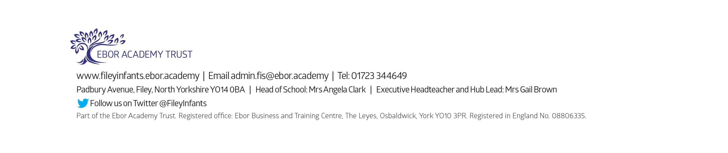
Head of School

