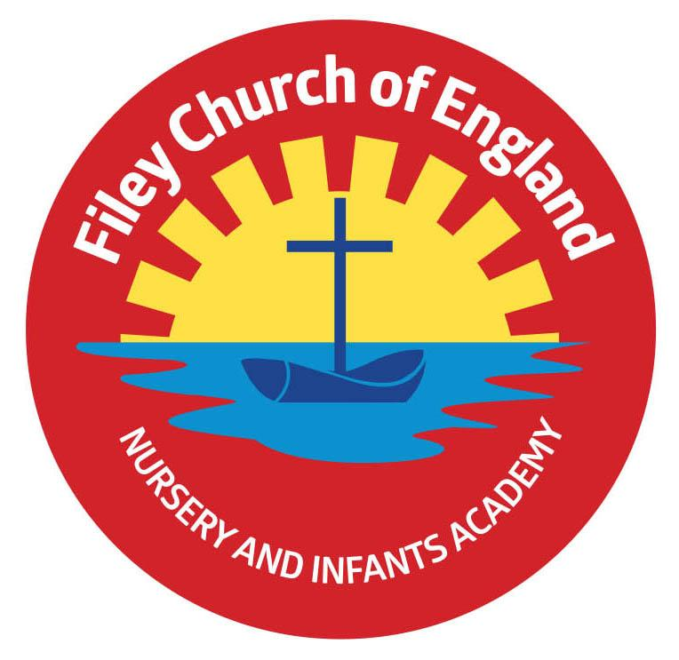
Friday 24th September 2021

Dear Parents/Carers

Another wonderful week in school! It has been great to see Family Reading club taking place on ‘Big Red’ the reading bus, with another amazing uptake!

Harvest Festival
This will take place on Friday 1st October at 9am in our school hall. It will only be our year 2 children taking part therefore we will only be inviting parents of year 2 children to attend. Year 1, Reception and Nursery children will record something special for Harvest and upload this onto the school website so family can share their celebrations.
All children will attend St John’s Church later that morning to deliver our Harvest gifts and celebrate Harvest Festival with Reverend Nigel.
Please send you Harvest gifts of fruit, vegetables, tins or packets into school on Thursday 30th September.

Free School Meals
If you have an annual household income of less than £16’190 your children could be entitled to free school meals. We know that all children in Reception, Year 1 & Year 2 are provided with a universal free meal anyway but please don’t let this stop you applying for Free School Meals if you think you might be entitled. As a school we receive extra funding for children eligible for FSM which enables us to offer extra support in school & extra-curricular activities.
Please ask Mrs Newlove in the office if you think you could be entitled or would just like more information.

‘Big Red’ the reading bus!
BBC Radio York will be visiting our reading bus on Wednesday 29th September. There will be four live broadcasts on this morning at approximately 7.15am, 7.40am, 8.15am and 8.40am. If you attend our family reading club and would like to say a few words live on the radio, please, please, please let me know!

Family Sponsored Walk - Friday 8th October
Your child should have brought a sponsor form home already to collect sponsors if you would like to help raise some money towards school funds. We will use some of this money towards taking all children to the Theatre in December, which is always a wonderful experience. You are invited to walk with us from school, down along the beach and back to school. If you are joining us the gates will open at 1pm where you will need to meet outside your child’s outside classroom door. This does not include Nursery, they do a little walk inside the school grounds without accompanying adults. They are still welcome to collect sponsors on a form if they would like.

Miss Williams Poetry Assembly – Friday 15th October
Parents are invited to attend if their child is in Miss Williams’s class. This will take place in the school hall at 9am.

Reading Books
Mrs Stubbs will be holding two sessions to explain how our new reading system in school works. These sessions will explain how our new reading books link to phonic phases, how they are used in school, what can be done at home and the progression through year groups.
Please come along to one of these sessions: Monday 27th September 2021 at either 2.30pm OR 4.30pm, they will take place in the school hall.

Remember to follow us on Twitter to see all the lovely things happening in school and check our school website for further information. Thank you for your continued support. Please keep the updated diary dates below for your information.

Best Wishes
Mrs Angela Clark
Angela Clark
Head of School

Diary Dates
Monday 27th September – Open the Book Collective Worship
Monday 27th September – Reading Meetings either 2.30pm OR 4.30pm
Monday 27th September – Closing date for Parent Governor Nominations

Friday 1st October – Year 2 Harvest Festival 9am in the school hall
Friday 1st October – Stephen Joseph Theatre workshops in school
Friday 8th October - Stephen Joseph Theatre workshops in school
Friday 8th October – Family sponsored walk 1pm
Monday 11th October – Parents Evening – 3pm-5pm
Tuesday 12th October – Parents Evening – 3pm-5pm
Wednesday 13th October – Parents Evening – 3pm-5pm
Friday 15th October – Miss Williams Poetry Assembly – 9am in the school hall
Thursday 21st October – Miss Williams Class Enterprise – 9am in the school hall
Thursday 21st October – Mrs George’s Class Enterprise – 2.30pm in the school hall
Friday 22nd October – Miss Haldenby’s Class Enterprise – 9am in the school hall
Friday 22nd October – School closes for half term

Monday 1st November – School reopens

