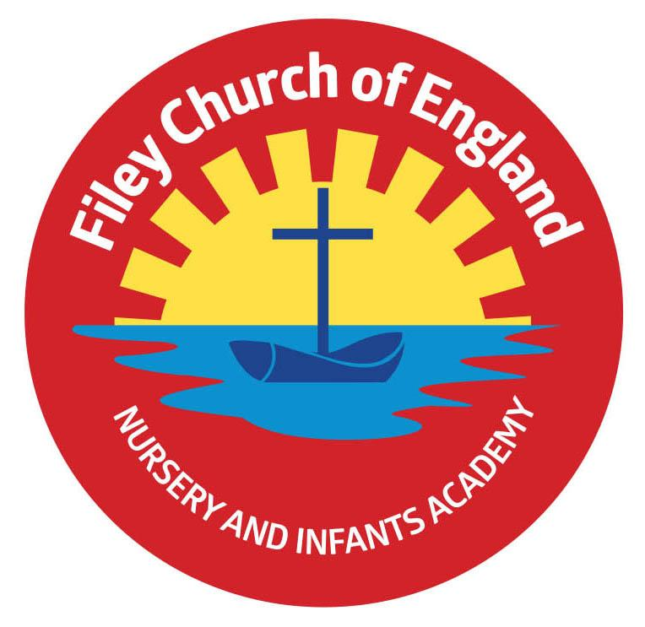
Friday 17th September 2021

Dear Parents/Carers

Another wonderful week in school! It has been great to see Family Learning sessions starting again with such an amazing uptake.

Family Sponsored Walk
We have needed to change this date! The sponsored walk will now take place on Friday 8th October at 1pm. You are invited to walk with us from school, down along the beach and back to school. If you are joining us the gates will open at 1pm where you will need to meet outside your child’s outside classroom door. This does not include Nursery, they do a little walk inside the school grounds without accompanying adults. They are still welcome to collect sponsors on a form if they would like.

‘Big Red’ the reading bus!
We have had a super response to our family reading club, so much so that we now need to offer two different days!
These sessions will take place each week on either Monday OR Wednesday (please only come to one session each week). They will take place on ‘Big Red’ the reading bus and start at 2.40pm. Parents/grandparents are welcome to come and read with their child on the reading bus. Children will collect a sticker each time they attend the club with a grown up and earn prizes. If you have not returned your letter and are interested, please phone the school office to register.

Attendance
It is vital for all children to attend school and minimise as far as possible the longer-term impact of this pandemic on our children’s education, wellbeing and wider development.
At this time of year we know many children experience coughs and colds. If your child is well enough to come to school please DO NOT keep them at home because they have a cold unless you think they may have symptoms of coronavirus, then you need to arrange a test.

If your child is going to be absent from school it is important that you contact school and let us know. Schools have a legal duty to register all children each morning, if we are unable to establish the whereabouts of a child we will need to make a home visit. If contact is still not made we will need to contact the police for assistance. PLEASE remember to let us know!

Reading Books
Mrs Stubbs will be holding two sessions to explain how our new reading system in school works. These sessions will explain how our new reading books link to phonic phases, how they are used in school, what can be done at home and the progression through year groups.
Please come along to one of these sessions: Monday 27th September 2021 at either 2.30pm OR 4.30pm, they will take place in the school hall.

School Parent Governor
We have a vacancy for a parent governor, letters were emailed to everyone yesterday. If you are interested please come and collect a nominations paper from the school office. These need to be returned by Monday 27th September 3pm.

School Photo Day
Thursday 23rd September will be our individual school photo day. If you would like your child to have their photograph taken with siblings not attending our school you will need to arrive between 8.30am and 9am. Siblings in our school will automatically have a photograph taken together as well as an individual photo. Nursery children that do not attend our Nursery on this day are invited to bring their child to school at 10am if they would like their photograph taking. Please come to the main reception area.

Remember to follow us on Twitter to see all the lovely things happening in school and check our school website for further information. Thank you for your continued support. Please keep the updated diary dates below for your information.

Best Wishes
Mrs Angela Clark
Angela Clark
Head of School

Diary Dates
Thursday 16th September – Year 2 after school PE club with Mr Ellis starts 3pm-4pm.
Tuesday 21st September – ‘Sparklers’ church group for year 2 at St John’s Church 3.45pm-4.45pm – please phone the school office to register a place.
Thursday 23rd September – School Photo Day am
Monday 27th September – Open the Book Collective Worship
Monday 27th September – Reading Meetings either 2.30pm OR 4.30pm
Monday 27th September – Closing date for Parent Governor Nominations

Friday 1st October – Harvest Festival (more information to follow)
Friday 1st October – Stephen Joseph Theatre workshops in school
Friday 8th October - Stephen Joseph Theatre workshops in school
Monday 11th October – Parents Evening – 3pm-5pm
Tuesday 12th October – Parents Evening – 3pm-5pm
Wednesday 13th October – Parents Evening – 3pm-5pm
Friday 15th October – Miss Williams Poetry Assembly – 9am in the school hall.
Friday 22nd October – School closes for half term

Monday 1st November – School reopens

