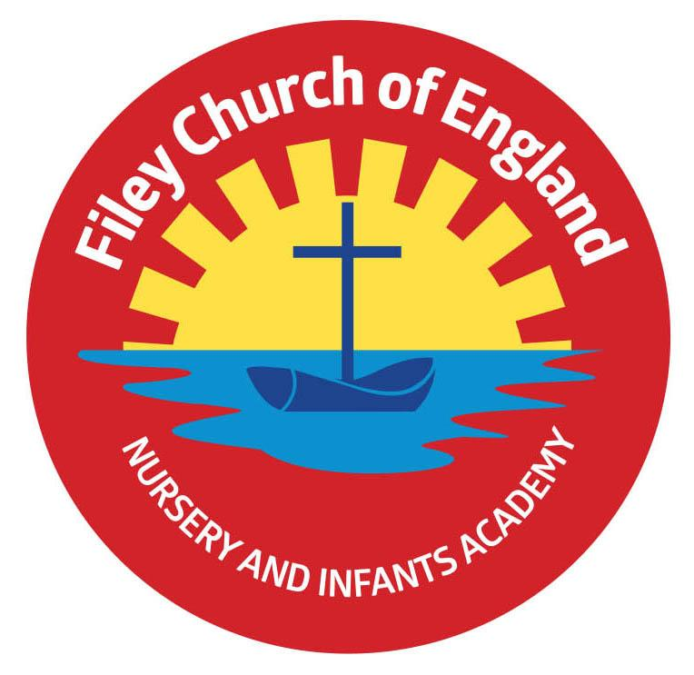
Friday 10th September 2021

Dear Parents/Carers

What a wonderful week we have all had back at school. The children have confidently entered school each morning and enjoyed being in their new classes. It has been such a delight to see the children all playing together again in the outdoor areas.

Free Breakfast
Each morning we offer free breakfast in the classrooms at 8.40am. This is includes a choice of cereal with milk and a drink of water. Your child will bring home a letter today with a return slip so you can indicate whether you would like your child to have breakfast each morning or not. Please return this slip on Monday morning to ensure your child receives breakfast.

Water Bottles
Children are welcome to bring a water bottle to school so we can avoid using the water fountains (due to Coronavirus). Please ensure the bottle is named and just contains water.

Covid-19 Risk Assessment
The up to date Covid-19 risk assessment is available for you to read on our school website, under: Key Info – Covid.

Milk
All children under the age of 5 receive free milk in school. If your child is 5 or older and you would like them to have milk in school you will need to pay for this via coolmilk.com
Please note: If your child is entitled to free school meals you will not need to pay for milk.

It’s Good to Grow
If you shop in Morrison’s supermarket please save us the ‘grow tokens’. These tokens will enable us to receive FREE gardening equipment for our children to use in school.

Tesco Tokens
Please remember to ask for your Tesco tokens and post them in the box so we can hopefully collect £1500 to go towards the library bus conversion.

‘Big Red’ the reading bus!
Our wonderful school library is all finished inside, we are just waiting for the sign writing to make it look super special. We will be starting our family reading club Monday 20th September. It will take place on ‘Big Red’ and starts at 2.40pm. Parents/grandparents are welcome to come and read with their child on the reading bus. Children will collect a stamp each time they attend the club with a grown up and earn prizes. Look out for the letter coming home next week.

School Parent Governor
We have a vacancy for a parent governor, if you are interested please look out for the letter going out next week.
‘Sparklers’ Church Group – Year 2
‘Sparklers’ church group for children and their parents will be held at St John’s Church in the Parish Hall room from Tuesday 21st September 3.45pm – 4.45pm. Children will enjoy Bible stories, craft activities and refreshments will be provided. Places are limited so if you would like to attend please phone the school office to register.

Reading Books
Please note that the individual reading books your child will be bringing home no longer follow a colour banded system. Reading books now match the phonic phase your child is working on in school. We will organise a session for parents/carers in school shortly to explain how this new system works.

Dogs
Just a polite reminder that dogs are not permitted on school grounds.

Remember to follow us on Twitter to see all the exciting things happening in school and check our school website for further information. Thank you for your continued support. Please keep the diary dates below for your information.

Best Wishes
Mrs Angela Clark
Angela Clark
Head of School

Diary Dates
Tuesday 14th September – Family Learning - group 1 commences 9am-11am.
Wednesday 15th September – Family Learning – group 2 commences 9am-11am.
Thursday 16th September – Family Learning – group 3 commences 1pm-3pm.
Thursday 16th September – Year 2 after school PE club with Mr Ellis 3pm-4pm.
Tuesday 21st September – ‘Sparklers’ church group for year 2 at St John’s Church 3.45pm-4.45pm.
Thursday 23rd September – School Photo Day am
Thursday 23rd September – Family Sponsored Walk pm

Monday 11th October – Parents Evening – 3pm-5pm
Tuesday 12th October – Parents Evening – 3pm-5pm
Wednesday 13th October – Parents Evening – 3pm-5pm
Friday 15th October – Miss Williams Poetry Assembly – 9am in the school hall.
Friday 22nd October – School closes for half term
Monday 1st November – School reopens

