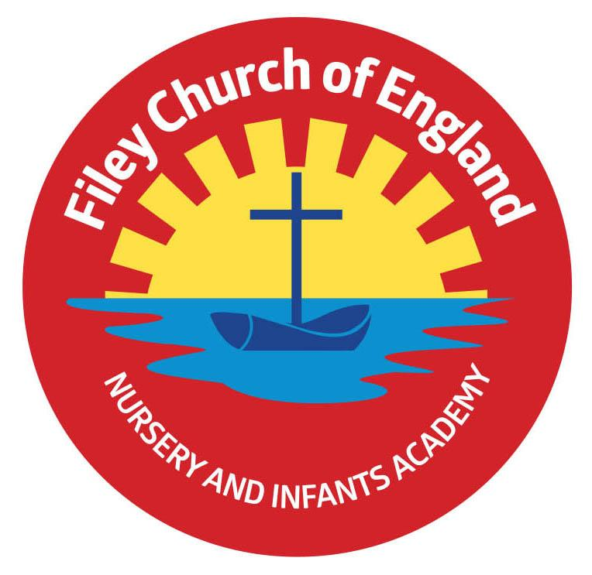
Wednesday 7th July 2021

Dear Parents/Carers

Following the Government’s announcement to lift many Covid-19 restrictions on Monday 19th September I am now in a position to outline the drop off and collection systems for September 2021. If Government guidance changes before we return to school on Tuesday 7th September we will let you know as soon as possible. Please see below the drop off and collection routines for each year group:
Nursery
Morning sessions start at 9am till 11.30am, afternoon sessions start at 12.30pm till 3pm.
Lunchtime is from 11.30am till 12.30pm, if your child would like a school lunch this is charged at £1.70 per day. Children will need to be brought to the Nursery door and handed over to a member of Nursery staff. They will be collected from the same place.

Reception Classes
If your child would like a free breakfast in the classroom, the start time is 8.40am. If your child is not having breakfast you should drop them off at 8.55am. Please note the gate will be locked at 9am prompt for security reasons. If you are late, you will need to sign your child in at the main office. Children should be handed over to staff at the Reception doors in a morning and collected from the same place at 3.05pm.

Year 1 and Year 2 Classes
If your child would like a free breakfast in the classroom, the start time is 8.40am. If your child is not having breakfast you should drop them off at 8.55am. Please note the gate will be locked at 9am prompt for security reasons. If you are late, you will need to sign your child in at the main office. Year 1 and Year 2 children will be handed over to staff at the back school gate on Clarence Drive. At the end of the school day the gate will be opened at 3pm to enable you to collect your child from their external classroom door.

Seashells Before and After School Club
We run a very successful before and after school club for busy parents.
Before school club starts from 7.30am and includes breakfast £4.50 per day.
After school from 3.05pm till 5pm including snack £7 per day.
After school from 3.05pm till 6pm including snack £9 per day.
Breakfast + after school from 7.30am till 6pm including breakfast and evening snack £12 per day. This can be booked through Parent Pay or the school office.

Sports Day
We will still be following the safety measures we have planned for Year Group Sports Days despite Covid-19 restrictions being lifted on Monday 19th July. You should have received a paper copy letter regarding your child’s sports day. This outlines the systems we will be following to keep this occasion as Covid-19 safe as possible. You will need to return the slip indicating the number of spectator seats required. Unfortunately visitors will not be able to use our toilet facilities during their visit. Please help us by following our safety requests on these days.

Summer Raffle
At this time of year we would normally hold a school Summer Fair, like many things over the last few academic years this has not been possible. It is important that we continue to raise funds from time to time to pay for many of the little extras we provide in school. If you are able and would like to help us raise funds there will be four separate year group raffles held at each of our Sports Days. We have many prizes on offer including children’s scooters, paddling pools, toys, food and drinks hampers, shop vouchers and pamper sets etc. Your child will bring home a sheet of tickets, if you would like to take part please return the completed tickets to school with the money no later than Friday 16th July. Good Luck!

White Lodge Hotel Art Competition
A small group of our talented artists took part in an art project recently. They went to visit The White Lodge Hotel in Filey and made observational drawings of the Hotel. The winning drawings will be printed on the Hotels new children’s menu. Well done to everyone who took part and especially to Dexter and Liam whose drawings have been chosen. A big thank you to The White Lodge Hotel for donating £200 towards school funds.

Vacancy for a General Teaching Assistant Apprentice
We have an exciting opportunity to employ a Teaching Assistant Apprentice to start September 2021, 25 hours a week, Monday – Friday. We are looking for someone with a passion for working with young people and a desire to develop a career in this field. If you are interested in applying for this position please visit our school website, under: Ebor Academy Trust – Careers & Vacancies or if you would like more information please phone the school office on 344649.

Best Wishes
Angela Clark
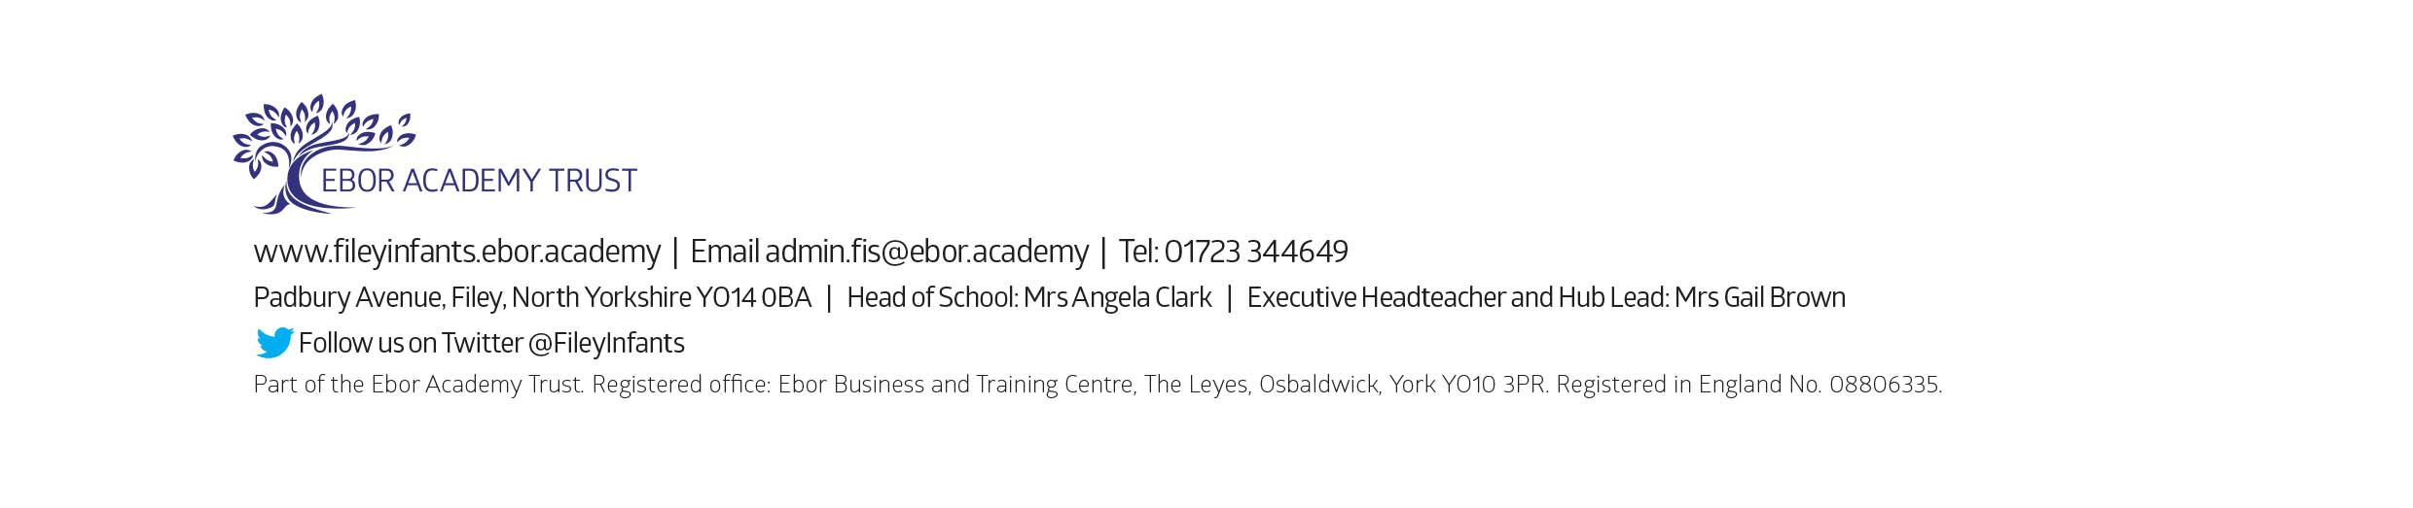
Mrs Angela Clark
Head of School

Dates for your Diary
Monday 12th July – Our Nursery children visit their new classroom and meet their new teacher.
Wednesday 14th July - Our Nursery children visit their new classroom and meet their new teacher.
Thursday 15th July – Year 2 ‘Outdoor Education’ day to Dalby Forest
Thursday 15th July – Reception and Year One children visit their new classroom and meet their new teachers.
Monday 19th July – 1.30pm Year 2 Sports Day (dependent on the weather & Covid-19 restrictions)
Tuesday 20th July – 1.30pm Year 1 Sports Day (dependent on the weather & Covid-19 restrictions)
Wednesday 21st July – 1.30pm Nursery Sports Day (dependent on the weather & Covid-19 restrictions)
Thursday 22nd July – 1.30pm Reception Sports Day (dependent on the weather & Covid-19 restrictions)
Thursday 22nd July – Year Two Leavers Party 5pm till 7pm
Friday 23rd July – Year 2 leavers assembly & family picnic on the school field (dependent on the weather and any changes to Covid-19 restrictions)
Friday 23rd July – School closes for the Summer holidays

Tuesday 7th September – School reopens for the Autumn term

