Friday 2nd July 2021

Dear Parents/Carers

As you are aware our usual pupil transition day format has needed to be changed due to the ongoing issues with Covid-19. We are mindful that children still need to meet their new teachers for September, get to know their new friends and see the classroom. I have outlined below how we will ensure some transition time is given to all children so they feel prepared for September. You will also receive an email on Friday 2nd July with a video link to a welcome message from your child’s new class teacher. We will not be needing any split year group classes again this year although I will be putting 8 of our more confident and mature year 1 children into a year 2 class in September (you will have already been informed if this is your child).

Year Two Transition
Yesterday our Year Two children had a visit from the Year Three teachers at Filey Junior School. They spent the whole morning getting to know the children and answered lots of questions. Mr McCarthy has invited all children and their parents to attend Filey Junior School for a short visit on either Thursday 8th or Friday 9th July (you should have been given an allocated time slot). It is our expectation that your child still attends our school on both these days and is absent for a short period of time in order to visit the Junior School.

Year One and Reception Transition
On Thursday 15th July our current Reception and Year 1 children will have the opportunity to spend some time with their new teachers during the school day and see their new classroom. This will hopefully alleviate any anxieties they may have before September and give them a chance to get to know their new friends and ask any questions.

Nursery Transition
Children that have been in our school Nursery and are moving into Reception in September will have the opportunity to meet their new teacher and see the classroom during the school day on Monday 12th July and Wednesday 14th July. Children from Filey Child Care have already made two visits and children from other settings have been given a date and time to attend.

Sports Days
You should have received a paper copy letter regarding your child’s sports day. This outlines the systems we will be following to keep this occasion as Covid-19 safe as possible. You will need to return the slip indicating the number of spectator seats required. Unfortunately visitors will not be able to use our toilet facilities during their visit. Please help us by following our safety requests on these days. We will be holding a fundraising raffle at each of our year group sports days, the ticket slips will be sent out next week.

Outdoor Education Days
Reception children had a wonderful time on the beach last week. A big thank you to Tracey and Steve for providing all our children with a free ice-cream!
Year One children had a wonderful time in Glen Gardens yesterday, taking part in lots of team building activities.
Year Two children will visit Dalby Forest on Thursday 15th July taking part in den building and treasure hunt activities.

September Routines
I am currently in the process of deciding on the drop off and collection routines for our children in September. As I am sure you can imagine this is not an easy task, especially when we do not know for certain what Covid-19 restrictions may be required. I will let you know as soon as possible.

DANGER!
Parents MUST NOT drive into the staff carpark at the front of school. Parents and children walk through this carpark and cars pulling in during the school day are a DANGER to our children. We will be closing the front gate to stop cars from entering this carpark during our busy drop off and collection times.

I have included an amended list of remaining dates for your dairy at the bottom of this letter. Although the restrictions around Covid-19 have eased, the rise of the Delta variant – which is significantly more transmissible – means it is still necessary to uphold our precautionary safety measures around school. Unless you have a recognised exemption, parents and carers MUST continue to wear face coverings while on school premises. If you have any questions or need help with anything please ask, we are here to help however we can.

Best Wishes
Angela Clark
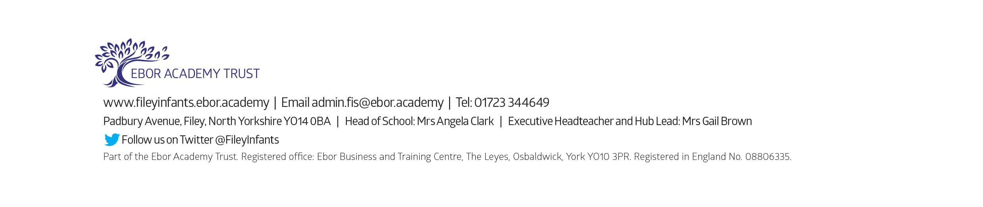
Mrs Angela Clark
Head of School

Dates for your Diary
Friday 2nd July – School reports go out to parents & welcome message from new teachers.
Monday 5th July – New Reception starters open evening (only 4 adults at a time).
Tuesday 6th July - New Reception starters open evening (only 4 adults at a time).
Monday 12th July – Our Nursery children visit their new classroom and meet their new teacher.
Wednesday 14th July - Our Nursery children visit their new classroom and meet their new teacher.
Thursday 15th July – Year 2 ‘Outdoor Education’ day to Dalby Forest
Thursday 15th July – Reception and Year One children visit their new classroom and meet their new teachers.
Monday 19th July – 1.30pm Year 2 Sports Day (dependent on the weather & Covid-19 restrictions)
Tuesday 20th July – 1.30pm Year 1 Sports Day (dependent on the weather & Covid-19 restrictions)
Wednesday 21st July – 1.30pm Nursery Sports Day (dependent on the weather & Covid-19 restrictions)
Thursday 22nd July – 1.30pm Reception Sports Day (dependent on the weather & Covid-19 restrictions)
Thursday 22nd July – Year Two Leavers Party 5pm till 7pm
Friday 23rd July – Year 2 leavers assembly & family picnic on the school field (dependent on the weather and any changes to Covid-19 restrictions)
Friday 23rd July – School closes for the Summer holidays

Tuesday 7th September – School reopens for the Autumn term

