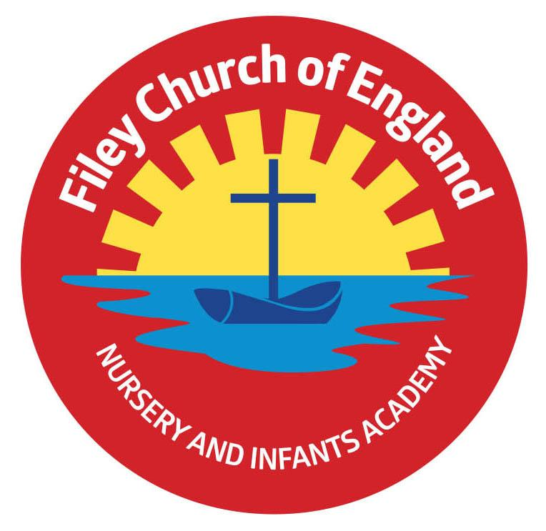

Friday 23rd July 2021

Dear Parents/Carers
Unfortunately the NHS Test and Trace app ‘pinged’ into my life on the penultimate day of the year! This means I am now one of over 600’000 people in the country having to self-isolate. Sadly this also meant I missed Reception Sports Day, Year 2’s Party, Leavers Assembly and Y2 family picnic. I did manage to watch the Y2 Leavers Assembly via the power of technology, which was a lovely celebration of 47 wonderful young people’s time in our school. At least I could have a little cry this year without anyone seeing me! It is also great to see the school is in such good hands when I am not there. I wish the Y2’s all the very best for their future and hope they enjoy the summer.
It is with a heavy heart that we say goodbye to Miss Beaumont and Mrs Rix this year. I thank them for their hard work and dedication, we will miss them greatly and send them all our best wishes for the future.

Summer Raffle
This was a huge success and we raised an amazing £593 towards all the little extras we like to get for the children in our school.

‘Big Red’ the Reading Bus
Conversion work will take place throughout the summer so the bus should be ready to use when we come back to school in September. I will invite our Y2 children to come back and have a story on the bus. Dexter and Jakob will also be invited to the opening ceremony to receive their prizes for naming the bus. ‘Big Red’ - Read, enjoy & discover!

Sports Days
Each year group sports days were great fun, we felt extremely lucky with the weather and thank everyone for their support. Photos from each afternoon can be viewed on our school website in the usual place: under TEACHING & LEARNING – your child’s class teacher’s name. They will all hopefully be uploaded by the end of today. Well done to everyone and a very special well done to our Nursery children for taking part too, their resilience and determination was a pleasure to see!

2020-2021 School Film
Miss Ring has put together a super school film of photos from throughout this year for you to enjoy. This will be uploaded onto the home page on our website.

Finally I would like to say a big thank you to everyone for their support and many kind words.
I hope you and your families have a lovely summer and I look forward to seeing you in September. School reopens on Tuesday 7th September.

Warm Wishes
Angela Clark
Angela Clark
Head of School

