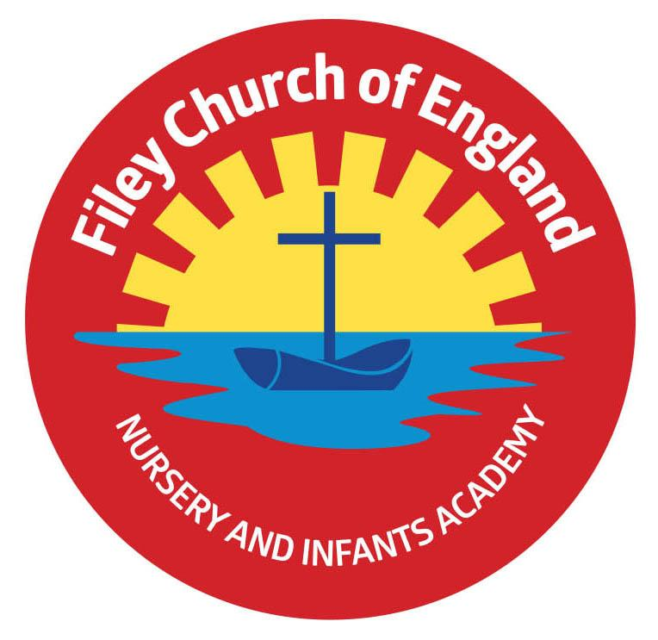
Friday 16th July 2021

Dear Parents/Carers
With the summer holidays nearly upon us I would like to take the opportunity to thank everyone for their wonderful support in what has been yet another tricky year! All the staff at Filey CE Nursery & Infants Academy have yet again worked tirelessly to ensure the children in our care have still received an enjoyable and engaging curriculum despite being in the midst of a global pandemic.

Our year two children had a wonderful time yesterday on their outdoor education day even though they had to stay in Filey rather than the planned trip to Dalby Forest! Dalby Forest do not allow double decker buses to drive through the forest which is why we booked a coach back in April. Sadly the coach company sent us a double decker bus without seatbelts, their mistake not ours!! The children were all very grown up and understood, I however, stamped my feet and vowed never to use that company again!
Check out their adventures on the school website. You will of course receive a refund of £5 that had been paid towards the transport.

TESCO Community Grants Tokens!!
Please, please, please ask everyone you know to vote for us and post their Tesco blue tokens for our Big Red Reading Bus scheme. If we receive the highest number of votes Tesco will give us £1500 towards our bus conversion, which is due to take place this summer. We will invite the Junior school to bring our year 2 children back in September to have a story on the bus once it is finished.

Sports Day
We are very much looking forward to traditional sports days this year, weather permitting! Covid-19 safety measures will still be followed despite restrictions being lifted on Monday 19th July. You should have received a paper copy letter regarding your child’s sports day. This outlines the systems we will be following to keep this occasion as Covid-19 safe as possible. You will need to return the slip indicating the number of spectator seats required. If you have not returned this slip and would like spectator seats please phone the school office. Unfortunately visitors will not be able to use our toilet facilities during their visit. Please help us by following our safety requests on these days. Children are invited to come to school that day already wearing their PE clothes. If the weather is hot please ensure your child has sun cream, a sun hat and a water bottle.

Summer Raffle
Wow! We have so many wonderful prizes, a BIG thank you to Mia, Phoebe and their mums Lindsey and Natalie for asking all the local businesses in Filey to donate. You will still be able to purchase raffle tickets on the afternoons of the year group sports days. Staff will be available to sell any last minute tickets between 1.10pm and 1.30pm on each of these days. Prizes include children’s scooters, remote control cars, stationary sets, food & wine hampers, pamper sets, shop vouchers, toys and much more!

Year 2 Leaver’s Assembly
Weather permitting the year 2 leaver’s assembly will take place on the school playground at 11.30am. Year 2 parents/carers only will be able to attend (please limit this to two people per child if possible). The gate at the back of school on Clarence Avenue will be opened from 11.10am until 11.30am to allow entry. If this event is unable to take place outside due to wet weather, it will still go ahead in the school hall without an audience. We will record this special event and share it with you on our school website.
Year 2 Leaver’s Party
Your child should have been given a letter regarding a leaver’s celebration party on Thursday 22nd July from 5pm – 6.30pm. Please return the slip provided if you would like to purchase a ticket for £3.00. The ticket price includes drinks, hotdog and ice-cream.

Family Picnic
The family picnic this year will be for our Year 2 children’s families only. This is to reduce the number of people within our school grounds. It will take place, weather permitting on the school field and will finish at 1pm. You are welcome to take your child home with you at this time should you wish to do so. School will still be open till the usual time on this day.

Attendance Letters
Every child will bring home an attendance letter on the last day of the year. This will give your child’s attendance for the full year. Children with 100% attendance will be congratulated with a certificate and a special keepsake badge.

September Routines
Providing there are no Covid-19 restrictions school gates will open from 8.40am in September for Reception, Year 1 and Year 2 children. Free breakfast is available in the classrooms at 8.40am for all children (including Nursery). If your child is not wanting breakfast they are welcome to play in the outdoor area from 8.40am until the bell rings at 8.55am (this does not include Nursery). The outdoor areas and the gates will be staffed for the safety of our children.

Activities for the Summer Holidays
Summer Dance Camp
If your child is entitled to free school meals there is the possibility of a free place at the Summer Dance Camp. Contact Mary-Ann Cartwright for more information on 07784130698 www.tadance.net
Filey in Bloom Summer Fayre Competition
If your child would like to make a Fairy Garden in a shoe box or decorate 6 Fairy Cakes, they could win a prize! Saturday 7th August, Crescent Gardens, Filey. Please see the attached leaflet for more information.
Summer Reading Challenge 2021
Filey Library have some exciting events happening this summer for children to enjoy. Please see the attached leaflet to find out more about ‘Wild World Heroes’.
Filey Cricket Club
6 weeks of sporting fun is available at Filey Cricket Club for ages 6+. If you are interested please contact David Brannan on 07966702985 or brann77@hotmail.co.uk
Free Training for Parents
If you are interested in learning more about your child’s mental health and wellbeing the NHS have free training available for parents. Please see the attached leaflet for more information. The training can be accessed through www.inourplace.co.uk with the code NYFAMILIES.

Once again, thank you to everyone for your wonderful support throughout the year. I hope you all have a lovely summer and look forward to the new academic year. School reopens on Tuesday 7th September.
Best Wishes
Angela Clark
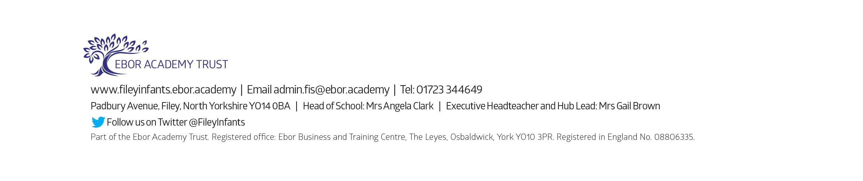
Mrs Angela Clark
Head of School

