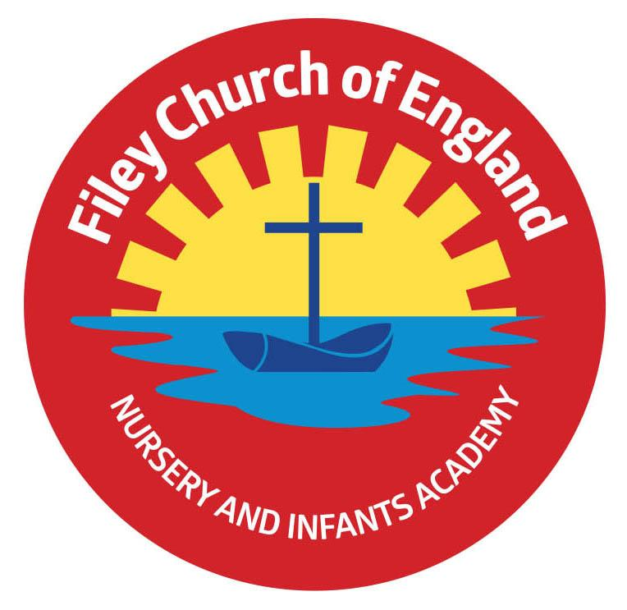
Wednesday 16th June 2021

Dear Parents/Carers

As I am sure you are aware the Government have now given Monday 19th July as the date that hopefully Covid-19 restrictions can be lifted. This does unfortunately now have implications for some of our planned school events. Please see below how this announcement has affected our school activities. We will of course continue to follow our school risk assessment and adhere to all safety systems.

Transition Days
Unfortunately we will now be unable to hold our planned transition days due to the ongoing Covid-19 restrictions. In order for year two children to meet their new teachers before September we will still invite their year three teachers into our school following a risk assessment so they can talk to the children and answer any questions. Junior school teachers will bring a PowerPoint of their school areas/routines to share with our children. Children will also have the opportunity to ask any questions that they may have.

Open Evening
Sadly we will no longer be able to hold a school open evening. Only children and parents that will be new to our school in September will be invited into school. They will be in groups of no more than 4 adults at a time (with two members of staff this keeps to the rule of 6, children under 5 do not count). This is very disappointing for everyone but we must adhere to Government guidelines.

New Classes for September
You will be informed of your child’s new class teacher for September via a letter included with your child’s school report. (Year 3 children will be informed via a letter from Filey Junior School). On Friday 2nd July 2021 we will also send you an email with a link to a welcome video message from your child’s new class teacher. You will be able to share this welcome message with your child at home and this will hopefully help to alleviate any anxieties they may have.

Year Two Leavers Party
We will still be having a year two leavers party after school on Thursday 22nd July from 5pm till 7pm. Look out for the letter coming home in a few weeks’ time.

Sports Day
I am very much hoping that separate year group sports days can still take place in the last week of term as planned. This will of course be dependent on Covid-19 restrictions being lifted and I may not be able to confirm this until the last minute.

Year Two Leavers Assembly & Family Picnic
Hopefully if Covid-19 restrictions are lifted on Monday 19th July our year two leavers assembly and family picnic will still go ahead as planned. Unfortunately I will be unable to confirm this until nearer the time. Either way this special assembly will be recorded and uploaded onto our school website for viewing.

Year One Outdoor Education Day
Due to the Met Office weather forecast showing a yellow warning for thunderstorms I have made the difficult decision to postpone this activity until Thursday 1st July. I suspect now this decision has been made the weather tomorrow will be wonderful, however it’s always far better to be safe rather than sorry!

Absence in Term Time
If you are taking your child on holiday during term time please complete a holiday form available from the school office. Holidays during term time cannot be authorised, however honesty is always the best policy especially as young children like to talk about their activities when they return to school.

Peter & the Wolf Art Competition
If your child would like to enter an art competition and have the chance of winning a wonderful prize please see the poster and information sheet attached to this email. It is open to children aged 4-14 and the winner will receive tickets to the York Symphony Orchestras Concert 2022 and a signed print by Gerard Hobson. The closing date is 20th July 2021.

I have included an amended list of remaining dates for your dairy at the bottom of this letter. Although the restrictions around Covid-19 have eased, the rise of the Delta variant – which is significantly more transmissible – means it is still necessary to uphold our precautionary safety measures around school. Unless you have a recognised exemption, parents and carers MUST continue to wear face coverings while on school premises. If you have any questions or need help with anything please ask, we are here to help however we can.

Best Wishes
Angela Clark
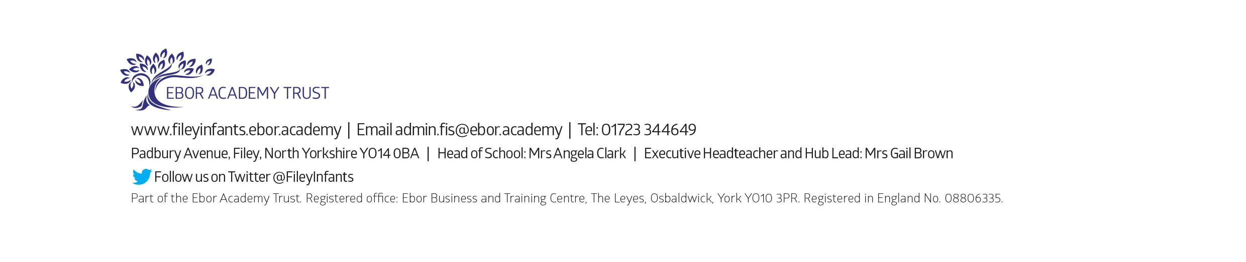
Mrs Angela Clark
Head of School

Dates for your Diary

June
Wednesday 16th June – Vision checks for year 1 children.
Tuesday 22nd June – After school PE sessions start for Year 2 children
Thursday 24th June – Reception ‘Outdoor Education’ day on Filey Beach

July
Thursday 1st July – Rearranged Year One ‘Outdoor Education’ day to Glenn Gardens
Friday 2nd July – School reports go out to parents
Monday 5th July – New Reception starters open evening (only 4 adults at a time).
Thursday 15th July – Year 2 ‘Outdoor Education’ day to Dalby Forest
Monday 19th July – 1.30pm Year 2 Sports Day (dependent on the weather & Covid-19 restrictions)
Tuesday 20th July – 1.30pm Year 1 Sports Day (dependent on the weather & Covid-19 restrictions)
Wednesday 21st July – 1.30pm Nursery Sports Day (dependent on the weather & Covid-19 restrictions)
Thursday 22nd July – 1.30pm Reception Sports Day (dependent on the weather & Covid-19 restrictions)
Thursday 22nd July – Year Two Leavers Party 5pm till 7pm
Friday 23rd July – Year 2 leavers assembly & family picnic on the school field (dependent on the weather and any changes to Covid-19 restrictions)
Friday 23rd July – School closes for the Summer holidays

September
Tuesday 7th September – School reopens for the Autumn term

