Friday 11th June 2021

Dear Parents/Carers
It has been a wonderful week back in school with children enjoying time outside in the sunshine. Please remember to apply sun cream in a morning or send sun cream into school with your child.
Sun hats are also advisable, please ensure your child’s name is written inside the hat.

Help Needed!
If anyone knows of a joiner or someone able to build book cases we would appreciate them getting in touch. We are looking for a quote to make and fit several book cases inside ‘Big Red’ (our school reading bus). The work can commence as soon as possible and ideally be finished by mid-August. We are also looking for any volunteers that might like to paint the book cases when they are finished or help with cleaning and organising books etc. If you would like to help us with this exciting project please phone the school office on 344649.

Change to Sports Day
We have decided that Reception and Nursery should have separate sports days in order to reduce the number of children and parents on the school field. The planned sports days are as follows:
Monday 19th July 1.30pm – Year Two Sports Day
Tuesday 20th July 1.30pm – Year One Sports Day
Wednesday 21st July 1.30pm – Nursery Sports Day (if your child does not normally attend Nursery on Wednesday afternoons and would like to take part, you are invited to bring them to the main office at 1pm on this day).
Thursday 22nd July 1.30pm – Reception Sports Day
These are all dependant on the weather and any future changes to Covid-19 restrictions.

Open Evening
We are hoping to hold an open evening in school this year to give everyone the opportunity to see their child’s work, meet their new teacher and see the new classroom. In order to keep this as safe as possible we need to limit the number of people in school at any one time. You will receive a time slot indicating when you can attend, if you need to change the time you can do so via the school office. We will be asking everyone to stay within their allocated time, wear face coverings and to hand sanitise on the way into the school building.

New Classes for September
You will be informed of your child’s new class teacher for September via a letter included with your child’s school report. These will be given out on Friday 2nd July 2021. If you would like to discuss your child’s school report with their class teacher this can be done on open evening: Tuesday 6th July.

Year Two Leavers Party
Hooray! We will be having a year two party this year! This is always great fun with music, hotdogs, ice-cream, games and prizes. This will take place in the school hall on Thursday 22nd July from 5pm till 7pm, tickets cost £3 and include hotdogs and ice-cream. Look out for the letter coming home in a few weeks.

Whole Class Photographs
If you would still like to order a class photograph and select the ‘deliver to school’ option, today is the last day, otherwise home delivery is available for £5 postage and packing. http://htmp.st/FileyCEInfantSchool If you need assistance please call Tempest Photography on 01736 751555 (option 3) or click on contact us on the home page.

I have included a list of all remaining dates for your dairy at the bottom of this letter. Please remember to continue wearing a face covering when dropping off and collecting your children from school. I thank everyone for their wonderful support, if you have any questions or need help with anything please ask, we are here to help however we can.

Best Wishes
Angela Clark
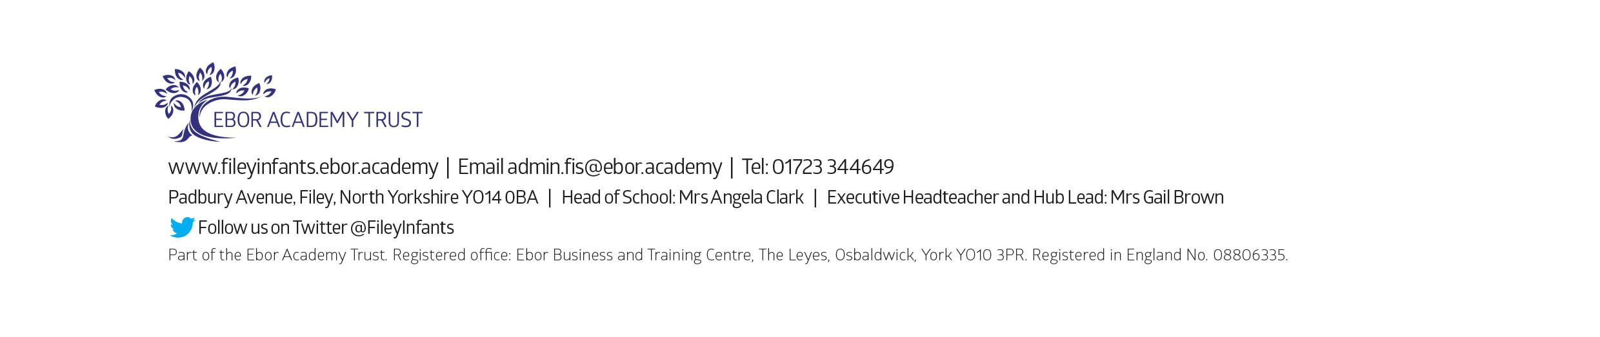
Mrs Angela Clark
Head of School

Dates for your Diary

JUNE
Tuesday 15th June – The last after school ‘Covid Catch Up’ groups commence
Tuesday 15th June – Vision checks for year 1 children.
Wednesday 16th June – Vision checks for year 1 children.
Thursday 17th June – Year 1 ‘Outdoor Education’ day to Glenn Gardens
Tuesday 22nd June – After school PE sessions start for Year 2 children
Thursday 24th June – Reception ‘Outdoor Education’ day on Filey Beach

JULY
Friday 2nd July – School reports go out to parents
Tuesday 6th July – Open Evening (time slots will be issued nearer the day)
Thursday 8th July – Transition day for all classes.
Friday 9th July – Extra transition day for year 2 children only.
Thursday 15th July – Year 2 ‘Outdoor Education’ day to Dalby Forest
Monday 19th July – 1.30pm Year 2 Sports Day (dependent on the weather & any changes to Covid-19 restrictions)
Tuesday 20th July – 1.30pm Year 1 Sports Day (dependent on the weather & any changes to Covid-19 restrictions)
Wednesday 21st July – 1.30pm Nursery Sports Day (dependent on the weather & any changes to Covid-19 restrictions)
Thursday 22nd July – 1.30pm Reception Sports Day (dependent on the weather & any changes to Covid-19 restrictions)
Thursday 22nd July – Year Two Leavers Party 5pm till 7pm
Friday 23rd July – Year 2 leavers assembly
Friday 23rd July – 12pm year two only family picnic on the school field (dependent on the weather and any changes to Covid-19 restrictions)
Friday 23rd July – School closes for the Summer holidays

Tuesday 7th September – School reopens for the Autumn term

