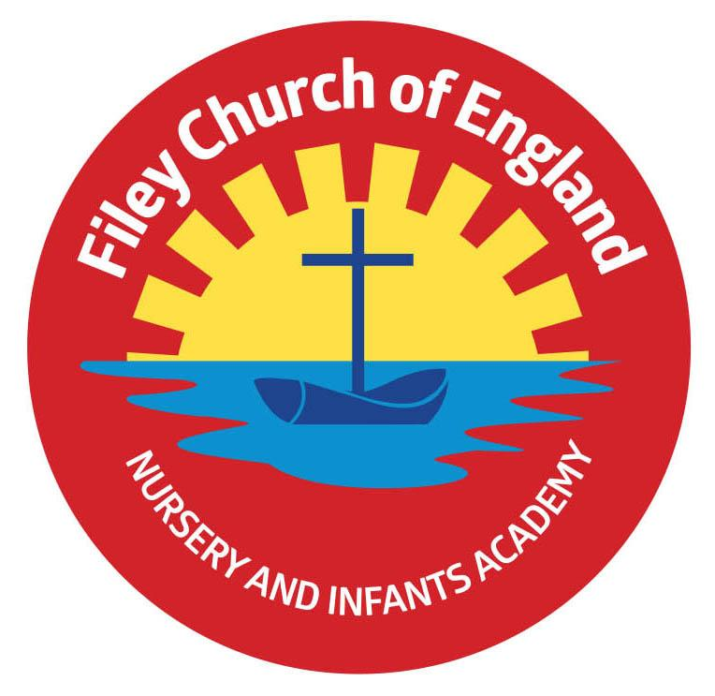
Friday 7th May 2021

Dear Parents/Carers

Hopefully now we are into the Summer term the weather will start to improve and classes will spend more time outside. Teachers are happy for your child to bring a named bottle of sun cream into school and apply their own lotion as needed. Alternatively you can apply lotion in the morning before school on sunny days. A sunhat is also advisable, please help us by writing your child’s name inside their hat.

SAFETY ISSUE
Please can all Nursery parents ensure that they hand their child over to a member of staff at the Nursery door when bringing them to school. The staff need to know your child has been handed over to them and have therefore become our responsibility. Although it is wonderful that our young children are happy and confident it is not safe enough to stand outside the school grounds and watch them come in. Please can all other year groups ensure their children have been safely seen to enter through our gates by a member of school staff. Thank you.

Whole Class Photographs
Class photos will be taken Thursday morning 20th May. If your child is on our NO PHOTO list they will NOT be included in this class photo unless you inform us otherwise. If you would like your Nursery child to be included in the photo and they are not normally in school on a Thursday morning you can bring them to our main reception area at 9.30am on this day and wait while they have the photograph taken.

Mental Health Awareness Week
Next week will be National Mental Health Awareness week 10th – 16th May. Here at Filey Infants we are always mindful of the importance of pupil and staff wellbeing and promote many activities in school to support positive mental health. Next week children will take part in yoga/mindfulness activities and begin to understand the links between nature and mental health. If you would like to take part in Mental Health Awareness week at home please see the attached power point of suggested activities. We would love to hear about your children’s experiences, please tweet @FileyInfants or email admin.fis@ebor.academy

School Absences
If your child is not going to be in school due to an illness or appointment it is important that you inform the school office daily before 9.30am. If we are not informed of your child’s absence we will do our best to contact you, however if we are still unable to make contact a welfare call will need to be made. It is a legal requirement for us to ensure all children are accounted for during school time.
If your child is absent due to a holiday please complete a form in advance, these are available from the school office.

Scholastic Book Club
Today is the last day to order books from The Scholastic Book Club.
Go to https://schools.scholastic.co.uk/filey-ce/digital-book-club to browse the latest books and order online. For every £1 you spend on this Book Club, our school will earn 20p. We will of course use this money to buy lovely new books for our reading bus!

PE Clubs
The last after school PE clubs for Reception children took place this week. From Tuesday 11th May and Thursday 13th May it will be the Nursery children’s turn to attend our after school PE club with Mr Ellis (specialist PE teacher). Please ensure you have returned the slip to sign up for a place.

Reception Performances
Look out for the Reception classes performances of ‘The Wellerman’ on our school website. These can be found under: TEACHING & LEARNING – Classes – Your child’s class teachers name and will be uploaded later today.

Please remember to continue wearing a face covering when dropping off and collecting your children from school. I thank everyone for their wonderful support, if you have any questions or need help with anything please ask, we are here to help however we can.

Best Wishes
Angela Clark
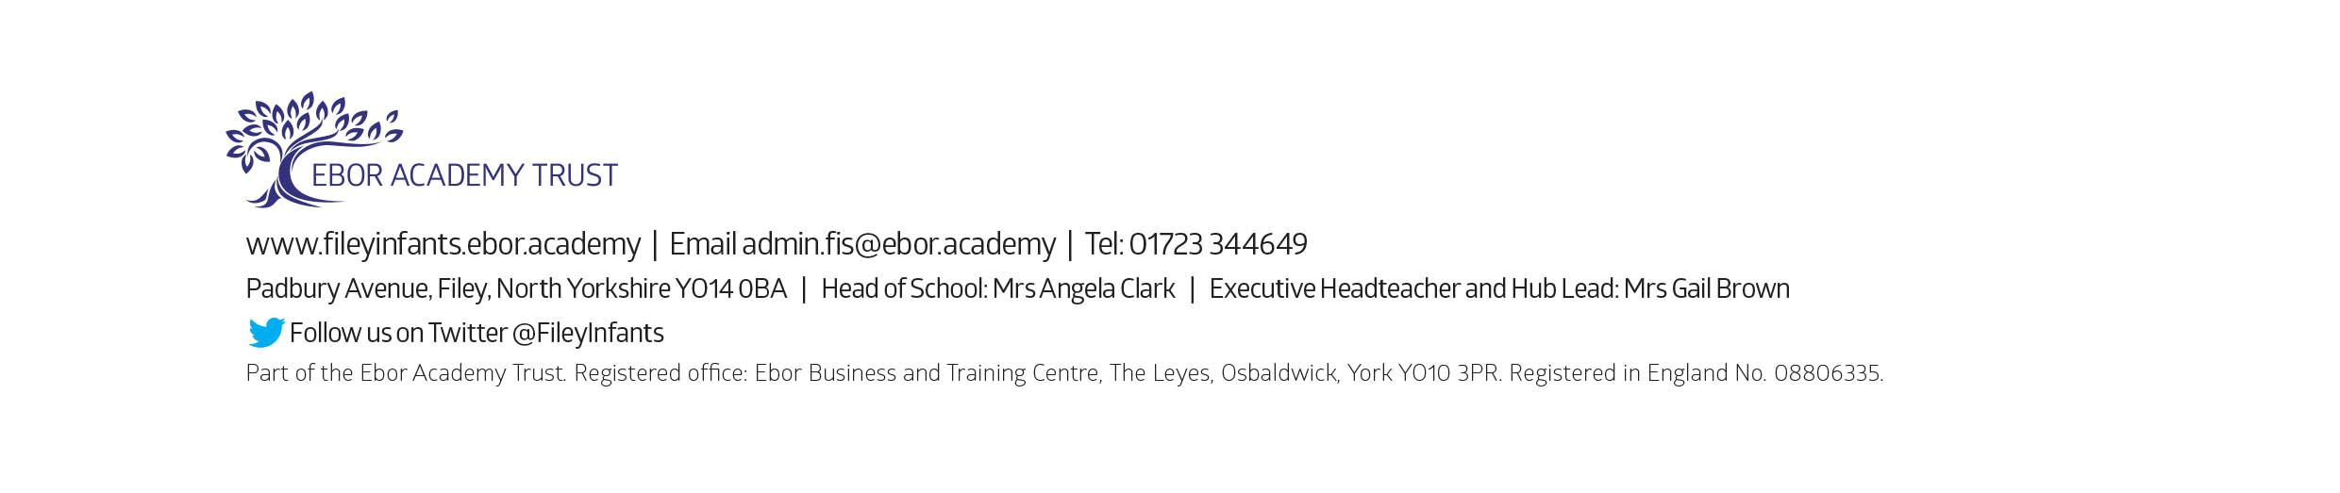
Mrs Angela Clark
Head of School

