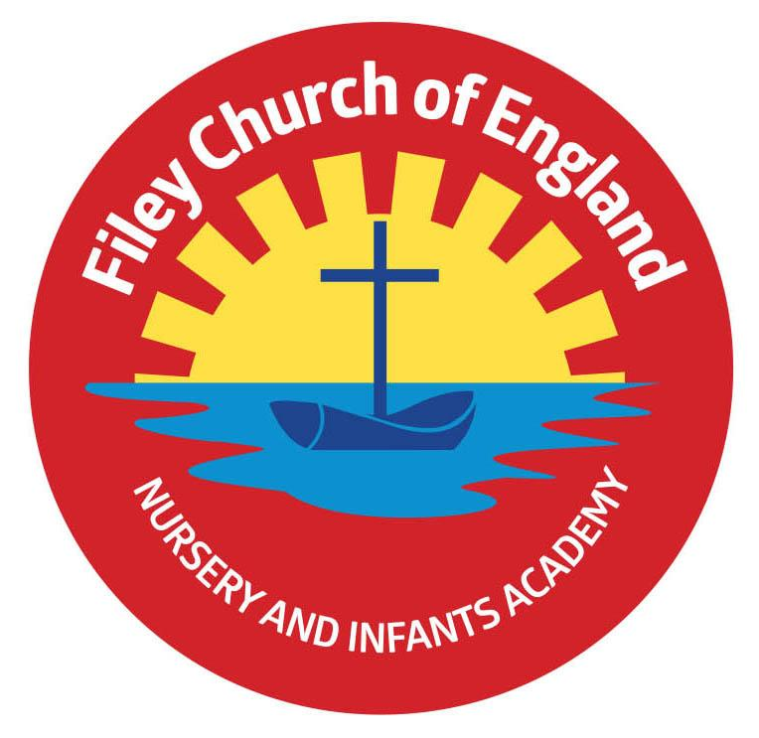
Thursday 27th May 2021
Dear Parents/Carers

Whole Class Photographs
The recent class photographs are now ready to view and purchase at http://htmp.st/FileyCEInfantSchool there will be a “deliver to school” option open for approx. 14 days, otherwise home delivery is available for £5 postage and packing. If you need assistance please call Tempest Photography on 01736 751555 (option 3) or click on contact us on the home page.

Head lice Combs
Head lice is an ongoing problem and recently we have had quite a few cases in our school. If your child does catch head lice it is important that you treat them as quickly as possible and do your best to avoid them missing school time. Using a special head lice comb is the best way to remove head lice. Wash your child’s hair and apply hair conditioner, while the conditioner is still on comb through your child’s wet hair with the special comb. If you then wipe the comb onto tissue paper you will see the head lice as small black dots. This will need repeating until all the head lice have been removed. Special solutions can be purchased from chemists if required. In order to help eliminate this problem and prevent children from missing school we have purchased 240 head lice combs. Each child will be given one of these special combs to bring home before the half term holiday. Please help us all by keeping this comb in a safe place and using it when needed.

Radio York, Scarborough Evening News and Yorkshire Live
Well! It seems our wonderful reading bus idea has caused quite a media interest. This morning myself, Mrs Stubbs, Lola and Sonny were interviewed by reporters from Radio York! They wanted to know all about our Big Red Reading Bus and the exciting plans ahead. If you would like to hear what was said you can follow this link https://www.bbc.co.uk/sounds/play/p09h8kg4 the times are 1:21:46, 1:43:45, 2:21:26, 2:44:10. Scarborough Evening News and Yorkshire Live have also put a report and photographs on their websites, this will also appear in our local newspaper over the coming weeks (keep a look out for this).

Sports Day
We would very much like to hold Sports Days this year and invite families to watch. In order to do this as safely as possible we have decided to hold three separate Sports Days for Nursery & Reception classes, Year 1 classes and Year 2 classes. This way we will have fewer adults on the school grounds at a time and we will be able to distance the seating for spectators. Please see the dates for these separate Sports Days at the bottom of this Newsletter.

Year Two Leavers Assembly
We would very much like to invite parents to our year two leavers assembly on Friday 23rd July at 11am. To make this possible we will need to hold the assembly outside in the open air. Unfortunately if the weather is unkind parents will not be able to attend, the assembly will then be recorded in the school hall and shared on our school website. Fingers crossed for a dry day!

Family Picnic
This year the family picnic will just be for our year two children and their families. The picnic will take place immediately after the leaver’s assembly and will of course be dependent on the weather. I hope everyone understands that because we are still unable to invite everyone at this time it is only fair that our year two leavers get to enjoy this special time together before they move onto the Junior School in September.

Free Cricket Taster Session
Scarborough Cricket Club are holding a free taster session for girls on Wednesday 2nd June. If you are interested please see the leaflet attached to this email.

Tennis Lessons at Hunmanby Hall
Hunmanby Hall are starting tennis coaching lessons from the 7th June, if you are interested please see the leaflet attached to this email.

I have included a list of all remaining dates for your dairy at the bottom of this letter. Please remember to continue wearing a face covering when dropping off and collecting your children from school. I thank everyone for their wonderful support, if you have any questions or need help with anything please ask, we are here to help however we can. I hope everyone has a lovely half term break and we very much look forward to being able to share as much as possible with you in the second half of our Summer term.

Best Wishes
Angela Clark
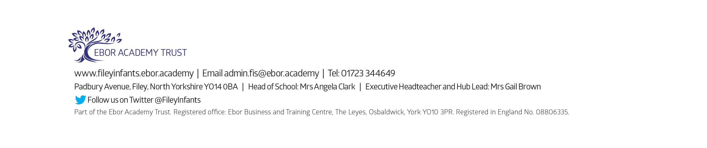
Mrs Angela Clark
Head of School

Dates for your Diary
Friday 28th May – Mr Jackson’s and Miss Beaumonts’ class poetry assemblies – these will be uploaded onto our school website by the end of the day.
Friday 28th May – School closes for half term

Tuesday 8th June – School reopens
Tuesday 15th June – The last after school ‘Covid Catch Up’ groups commence
Tuesday 15th June – Vision checks for year 1 children.
Wednesday 16th June – Vision checks for year 1 children.
Thursday 17th June – Year 1 ‘Outdoor Education’ day to Glenn Gardens
Tuesday 22nd June – After school PE sessions start for Year 2 children
Thursday 24th June – Reception ‘Outdoor Education’ day on Filey Beach
Friday 2nd July – School reports go out to parents
Tuesday 6th July – Possible Open Evening (details to be confirmed)
Thursday 8th July – Transition day for all classes.
Friday 9th July – Extra transition day for year 2 children only.
Thursday 15th July – Year 2 ‘Outdoor Education’ day to Dalby Forest
Monday 19th July – 1.30pm Year 2 Sports Day (dependent on the weather & any changes to Covid-19 restrictions)
Tuesday 20th July – 1.30pm Year 1 Sports Day (dependent on the weather & any changes to Covid-19 restrictions)
Wednesday 21st July – 1.30pm Nursery & Reception Sports Day (dependent on the weather & any changes to Covid-19 restrictions)
Friday 23rd July – Year 2 leavers assembly (uploaded onto the school website for viewing)
Friday 23rd July – 12pm year two only family picnic on the school field (dependent on the weather and any changes to Covid-19 restrictions)
Friday 23rd July – School closes for the Summer holidays
Tuesday 7th September – School reopens for the Autumn term

