Friday 14th May 2021

Dear Parents/Carers
Thank you so much to everyone who ordered books from the Scholastic Book Club, we raised a wonderful £62.64 for school to buy books for our reading bus.

Reading Bus Competition
Thank you to everyone who entered our name the reading bus competition. We have judged the entries and have chosen two winners! The winning name is a combination of two entries from Dexter Roland and Jacob Collins, they will both receive a £10 voucher to spend in Wrays.
Our bus is now called ‘BIG RED’ Read, Enjoy & Discover! We will have an opening ceremony once the bus has been fully converted.

Head Lice
From time to time young children do unfortunately catch head lice. Please help us in school by reading the attached head lice policy. If you have any questions please ask.

Sun cream & Sunhats
Teachers are happy for your child to bring a named bottle of sun cream into school and apply their own lotion as needed. Alternatively you can apply lotion in the morning before school on sunny days. A sunhat is also advisable, please help us by writing your child’s name inside their hat.

Whole Class Photographs
Class photos will be taken Thursday morning 20th May. If your child is on our NO PHOTO list they will NOT be included in this class photo unless you inform us otherwise. If you would like your Nursery child to be included in the photo and they are not normally in school on a Thursday morning you can bring them to our main reception area at 9.30am on this day and wait while they have the photograph taken.

School Absences
If your child is not going to be in school due to an illness or appointment it is important that you inform the school office daily before 9.30am. If we are not informed of your child’s absence we will do our best to contact you, however if we are still unable to make contact a welfare call will need to be made. It is a legal requirement for us to ensure all children are accounted for during school time.
If your child is absent due to a holiday please complete a form in advance, these are available from the school office.

Uniform Cupboard
We have a cupboard in school full of good quality used school uniform. Normally we encourage parents to come and help themselves to anything they can make use of from the cupboard but due to Covid-19 restrictions this has not been possible. We would very much still like to recycle as much as we can so if your child can make use of some extra uniform please phone the school office and tell us what you need. We can then bag up the items and give them to your child to bring home at the end of the day. Please note we have an abundance of lovely girls’ summer dresses! PLEASE PHONE!

Please remember to continue wearing a face covering when dropping off and collecting your children from school. I thank everyone for their wonderful support, if you have any questions or need help with anything please ask, we are here to help however we can.

Best Wishes
Angela Clark
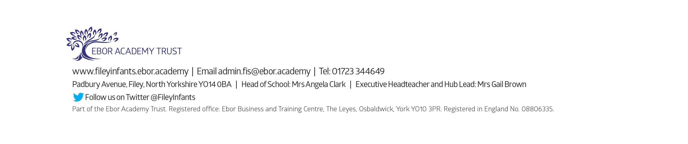
Mrs Angela Clark
Head of School

