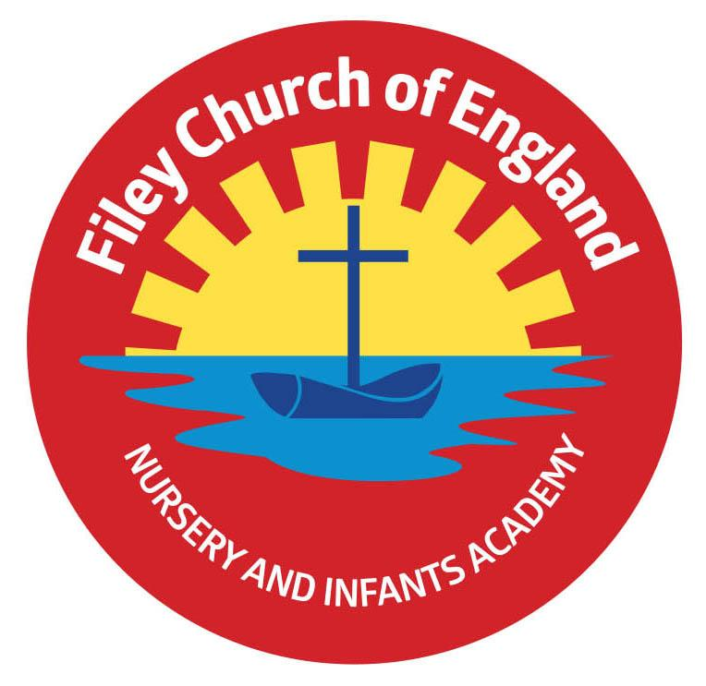
Friday 23rd April 2021

Dear Parents/Carers

YIPEEEEEE!! Finally our big red reading bus has arrived!
All the children and staff were delighted to see our double decker bus arrive this week. This bus will become our school library so children can enjoy reading together in an exciting environment.
A BIG thank you to Filey Churches Together for donating the money to help make this possible. COMPETITION TIME! We would like to name our school reading bus and offer a special prize for the winner. If you would like to take part please send your chosen name for our bus to school in an envelope by Friday 7th May. Remember to include your child’s name and which class they are in. GOOD LUCK! The winner will also take part in our grand opening ceremony!
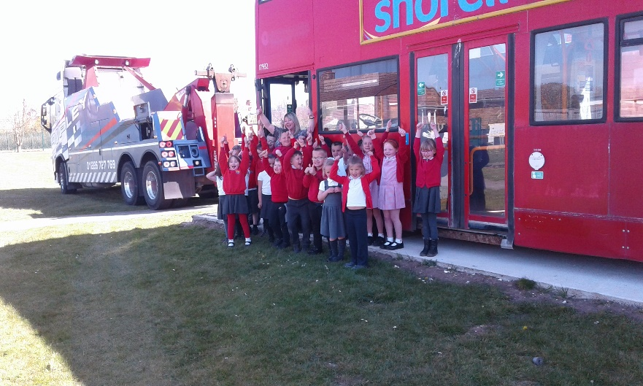
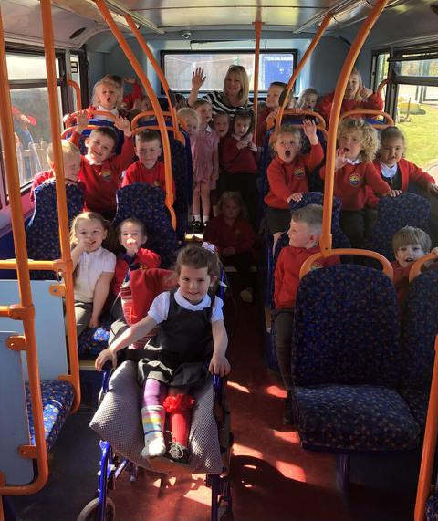

Scholastic Book Club
The Scholastic Book Club is up and running! Your child will have been given a brochure of books to bring home with them today. Go to https://schools.scholastic.co.uk/filey-ce/digital-book-club to browse the latest books and order online. For every £1 you spend on this Book Club, our school will earn 20p. We will of course use this money to buy lovely new books for our reading bus! Please place your order online by May 7th, 2021.

PE Clubs
The last after school PE clubs for Reception children will be on either Tuesday 4th May or Thursday 6th May (depending on which session they have attended). From Tuesday 11th May and Thursday 13th May it will be the Nursery children’s turn to attend our after school PE club with Mr Ellis (specialist PE teacher). Please ensure you have returned the slip to sign up for a place.

Catch up funding sessions
If your child has been attending an after school session for Phonics, Reading or Maths the last session will be in the week beginning 26th April. New sessions will then commence the following week. You will receive a letter next week if it is your child’s turn to attend these after school sessions. If you would like any more information or have any questions please talk to your child’s class teacher.

Cycling
If your child cycles to school please be safe and ensure they wear a cycle helmet. The roads are very busy around school with cars and various delivery vehicles. Unfortunately accidents do happen and it is always far better to be extra safe.

Yorkshire Coast Football Academy
If you have a daughter aged 5 or above who is interested in playing football please see the information leaflet from the Yorkshire Coast Football Academy attached to this email.

Ebor Academy Poetry Book
We're pleased to be able to advise that copies of our poetry book, comprising winners' and runners'-up poems in our Ebor schools poetry competition, are now available to buy online. If you would like to purchase one of these books and support the NSPCC please see the information letter attached to this email.

Please remember to continue wearing a face covering when dropping off and collecting your children from school. I thank everyone for their wonderful support, if you have any questions or need help with anything please ask, we are here to help however we can.

Best Wishes
Angela Clark
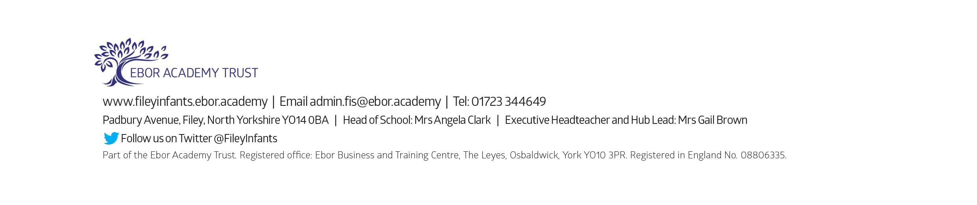
Mrs Angela Clark
Head of School

DIARY DATES

Monday 3rd May – School Closed – Bank holiday
Friday 7th May – Reception ‘Sea shanty’ online performances
Tuesday 4th May – New after school ‘Covid Catch Up’ groups commence
Friday 7th May – Closing date for our ‘name the bus competition’!
Friday 7th May – Last day to order books from the online Scholastic Book Club
Tuesday 11th May – After school PE sessions start for Nursery children
Friday 28th May – Mr Jackson’s and Miss Beaumont’s class poetry assemblies (online viewing)
Friday 28th May – School closes for half term

Tuesday 8th June – School reopens
Tuesday 15th June – The last after school ‘Covid Catch Up’ groups commence
Thursday 17th June – Year 1 ‘Outdoor Education’ day to Glenn Gardens
Tuesday 22nd June – After school PE sessions start for Year 2 children
Thursday 24th June – Reception ‘Outdoor Education’ day on Filey Beach
Friday 2nd July – School reports go out to parents
Tuesday 6th July – Possible Open Evening (dependent on Covid-19 restrictions)
Thursday 15th July – Year 2 ‘Outdoor Education’ day to Dalby Forest
Tuesday 20th July – 1.30pm Sports Day (spectators will be dependent on Covid-19 restrictions)
Friday 23rd July – Year 2 leavers assembly (uploaded onto the school website for viewing)
Friday 23rd July – 12pm family picnic on the school field (dependent on Covid-19 restrictions)
Friday 23rd July – School closes for the Summer holidays
Tuesday 7th September – School reopens for the Autumn term

Please note: Transition days into new classes are yet to be confirmed (due to Covid-19 restrictions)

