Friday 16th April 2021

Dear Parents/Carers

What a lovely start to the Summer term! The sun has been shining, all classrooms have been very busy and the Year 1 children have been investigating dinosaur footprints that appeared overnight on the playground!
Although the Covid-19 pandemic has stopped some of our planned activities we still have many wonderful experiences for our children to look forward to. Please keep the diary dates page at the bottom of this letter.

Stephen Joseph Theatre
Our Reception classes will be enjoying drama workshops in school this half term. These workshops are provided by Claire a drama teacher from The Stephen Joseph Theatre in Scarborough. The theme for these workshops is ‘Sea Shanties’ and will finish with a recorded performance for you to enjoy watching on our school website. Follow us on Twitter to see their progress!

PE Clubs
The last after school PE clubs for Reception children will be on either Tuesday 4th May or Thursday 6th May (depending on which session they have attended). From Tuesday 11th May and Thursday 13th May it will be the Nursery children’s turn to attend our after school PE club with Mr Ellis (specialist PE teacher). Look out for the letter coming home next week to sign up for a place.

Catch up funding sessions
If your child has been attending an after school session for Phonics, Reading or Maths the last session will be in the week beginning 26th April. New sessions will then commence the following week. You will receive a letter if it is your child’s turn to attend these after school sessions. If you would like any more information or have any questions please talk to your child’s class teacher.

Parent Consultations
Before the Easter holidays we held two parent consultation meetings for our new statutory RSE (Relationships and Sex Education) policy. Both meetings were very positive, with some super suggestions from parents. One suggestion was that we inform parents of the correct terminology schools use to name body parts, this way the same terminology can be used at home with your children. This is provided in the following table:
Year One | Year Two
5-6 year olds: I can identify the parts of the body that make boys different to girls and can use the correct names for these: penis, testicles, vagina, vulva, and anus. | 6-7 year olds: I can recognise the physical differences between boys and girls, use the correct names for parts of the body (penis, anus, testicles, vagina, and vulva) and appreciate that some parts of my body are private.
We will be using the ‘Jigsaw Mindful Approach to RSHE’ please see the leaflet for parents attached to this email. If you have any questions please phone the school office on 344649 or talk with your child’s class teacher.
Our school RSE policy is available to view on the school website.

Parent Phone Calls
Most teachers have now held their parent phone calls. If you have missed this opportunity to talk to your child’s class teacher and would still like to, please phone the school office to make an appointment.
Appointment days for next week are as follows:
Monday 19th April – Miss Beaumont 1pm-6pm
Tuesday 20th April – Mrs Stubbs 1pm-6pm
Thursday 22nd April – Miss Ring 1pm-6pm

If you have any questions or need help with anything please phone the school office, we are here to help however we can.

Best Wishes
Angela Clark
Mrs Angela Clark
Head of School
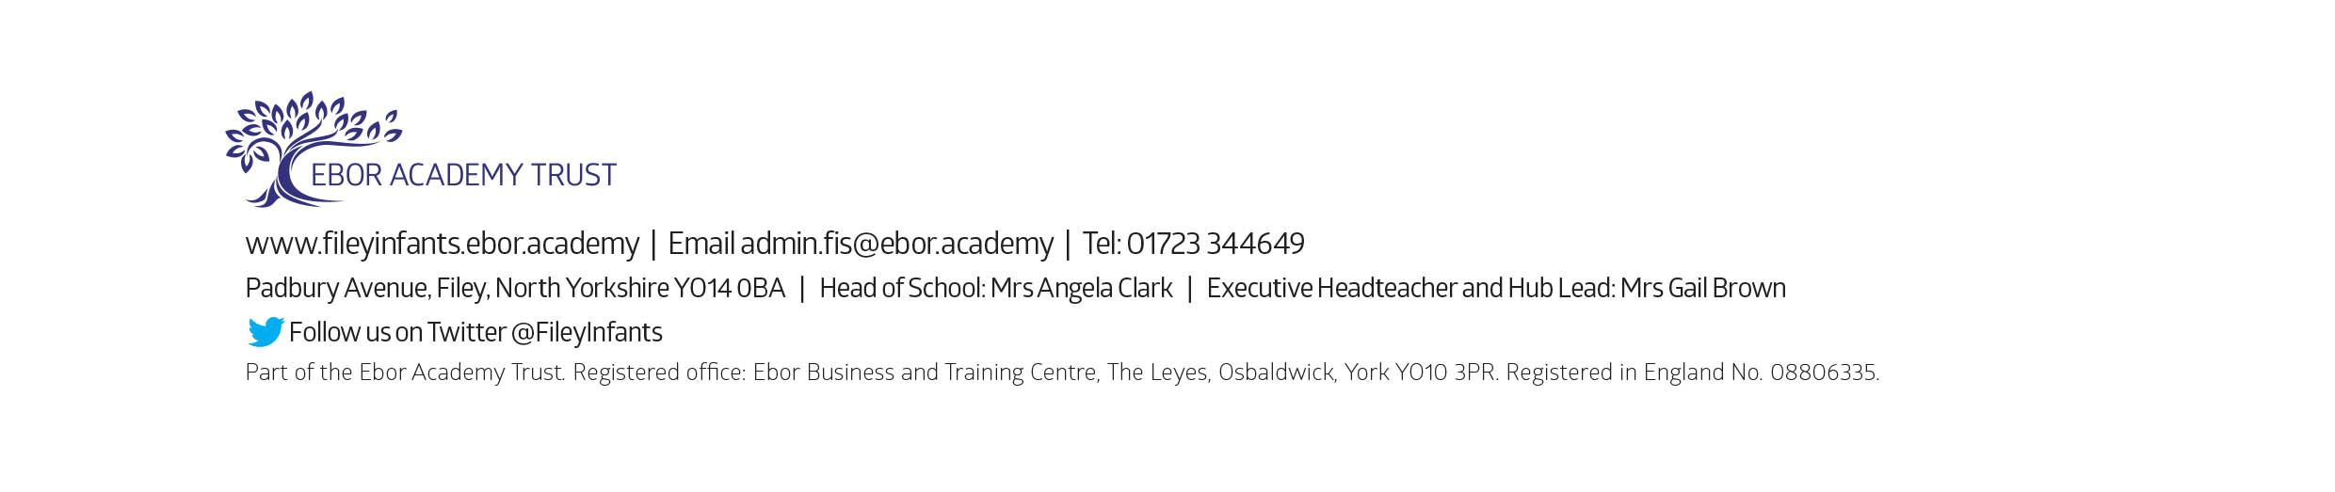
Diary Dates

Monday 19th April – Miss Beaumont’s Parent Phone Calls
Tuesday 20th April – Mrs Stubbs’ Parent Phone Calls
Thursday 22nd April – Miss Ring’s Parent Phone Calls
Monday 3rd May – School Closed – Bank holiday
Friday 7th May – Reception ‘Sea shanty’ online performances
Tuesday 4th May – New after school ‘Covid Catch Up’ groups commence
Tuesday 11th May – After school PE sessions start for Nursery children
Friday 28th May – Mr Jackson’s and Miss Beaumont’s class poetry assemblies (online viewing)
Friday 28th May – School closes for half term

Tuesday 8th June – School reopens
Tuesday 15th June – The last after school ‘Covid Catch Up’ groups commence
Thursday 17th June – Year 1 ‘Outdoor Education’ day to Glenn Gardens
Tuesday 22nd June – After school PE sessions start for Year 2 children
Thursday 24th June – Reception ‘Outdoor Education’ day on Filey Beach
Friday 2nd July – School reports go out to parents
Tuesday 6th July – Possible Open Evening (dependent on Covid-19 restrictions)
Thursday 15th July – Year 2 ‘Outdoor Education’ day to Dalby Forest
Tuesday 20th July – 1.30pm Sports Day (spectators will be dependent on Covid-19 restrictions)
Friday 23rd July – Year 2 leavers assembly (uploaded onto the school website for viewing)
Friday 23rd July – 12pm family picnic on the school field (dependent on Covid-19 restrictions)
Friday 23rd July – School closes for the Summer holidays
Tuesday 7th September – School reopens for the Autumn term

Please note: Transition days into new classes are yet to be confirmed (due to Covid-19 restrictions)

