Friday 23rd April 2021

Ebor Academy Poetry Book
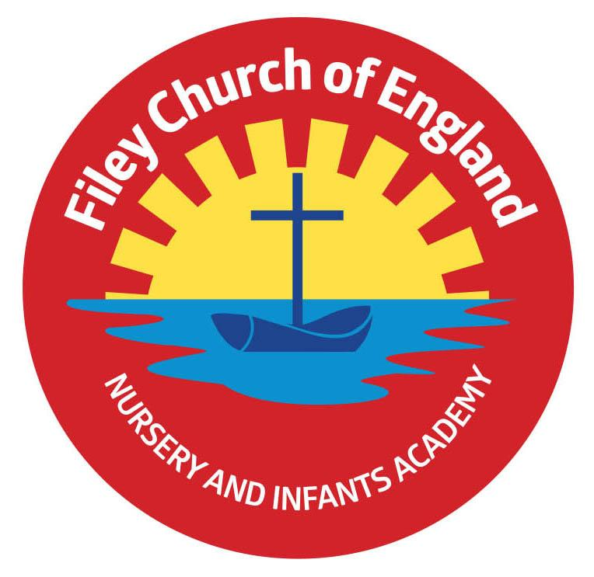
Dear Parent/Carer

We're pleased to be able to advise that copies of our poetry book, comprising winners' and runners'-up poems in our Ebor schools poetry competition, are now available to buy online.

As well as the poems, our budding poets from schools across Ebor Academy Trust also have their photograph next to them. The theme is 'looking forwards' to life after lockdown and the books will be a permanent but optimistic reminder of this historic time. There is some beautiful poetry from children of all ages as well as staff.

Priced at £5 including postage, all proceeds go to the vital work carried out by children's charity the NSPCC. Here's the link: https://bit.ly/3dsRMxs - note, while it says 'Tickets' on the website, this is actually to make a purchase of the book.

The NSPCC tell us they will despatch books within a week of receiving the order.

Books are only being sold online because of continuing Covid restrictions, which rules out money changing hands. It is not possible to buy books any other way.

The NSPCC's Childline telephone help service, for children and young people, costs £4 per call. Every poetry book bought pays for a call which helps a child.

We are grateful to Agilico Workplace Technology for sponsoring the book token prizes awarded to winners and runners-up and for the professional production of the poetry books.

Thanks all!

