Friday 26th March 2021

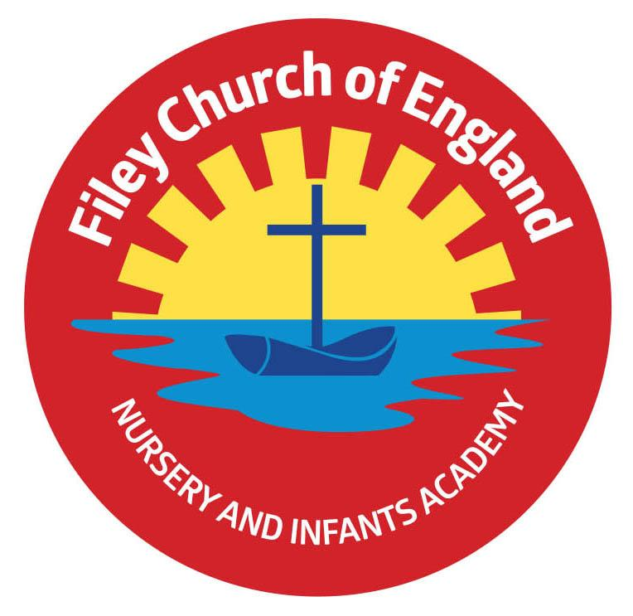
Dear Parents/Carers
Well done to everyone who entered the decorated egg competition. Thank you to Diane Lamb from the Filey Food Cupboard for the donated Easter egg prizes. There were so many wonderful creations it was very difficult for Mrs Wilson to choose the winners.

FEAST North Yorkshire
North Yorkshire Together have provided activity packs for all our free school meal children in Reception, Year 1 and Year 2. The activity pack is the first instalment from FEAST, a brand new holiday food and activity programme that is being delivered throughout North Yorkshire in the Easter, Summer and Christmas holidays this year. If your child is registered for free school meals and in either Reception, Year 1 or Year 2, look out for the wonderful blue bag of activities coming home.

Colgate Bright Smiles
Supporting the delivery of oral health education to 5-7 year olds, Colgate have provided our Year 1 and Year 2 children with a toothpaste sample, a toothbrush and an educational family leaflet. This is the perfect way to educate your children about the importance of good oral health. Please make use of these free samples and promote ‘Bright Smiles, Bright Futures’.

Nursery Admissions
As I am sure you all know we run a very successful Nursery within school. If you know of any families with children aged 3 before the 31st August please remind them to contact school as soon as possible, we are in the process of booking places for September 2021.

Parent Consultations
This week we held two parent consultation meetings for our new statutory RSE (Relationships and Sex Education) policy. Both meetings were very positive, with some super suggestions from parents. Thank you to those who attended it was very much appreciated. We will be sending a leaflet out after the Easter holiday highlighting the correct terminology we will be using in class to name parts of the body (as suggested by parents during the meeting). The policy will also be uploaded onto our school website at the start of the Summer term.

Parent Phone Calls
Nursery and Reception teachers have now held their parent phone calls. Year 1 and Year 2 teachers will be holding theirs after the Easter holidays. Please remember to sign up for a suitable time slot to talk to your child’s class teacher about their wellbeing and progress in school. If you no longer have the time slot letter please phone the school office to make your appointment.
Wednesday 14th April – Mr Jackson 1pm–6pm
Thursday 15th April – Miss Williams 1pm–6pm
Monday 19th April – Miss Beaumont 1pm-6pm
Tuesday 20th April – Mrs Stubbs 1pm-6pm
Thursday 22nd April – Miss Ring 1pm-6pm

School reopens on Tuesday 13th April and our after school clubs will start again straight away from the first day back. I hope you all have an enjoyable Easter and as always I thank you for your many kind words and continued support. If you have any questions or need help with anything please phone the school office, we are here to help however we can.

Best Wishes
Angela Clark
Mrs Angela Clark
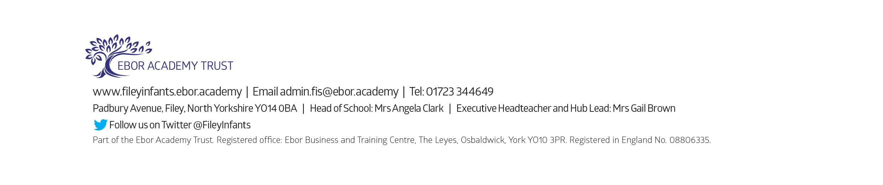
Head of School

