Friday 19th March 2021
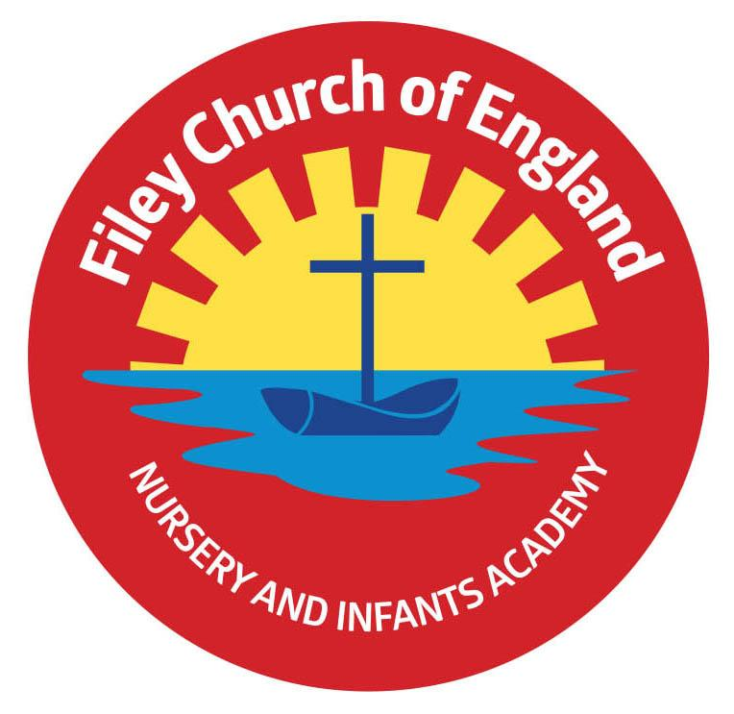
Dear Parents/Carers

This week we held interviews for our school Deputy Headteacher and I am pleased to announce that Mrs Hannah Stubbs will take up this position after the Easter holidays. A very big thank you to Mrs Julie George for supporting me as Acting Deputy during this interim period.

Red Nose Day
Thank you to everyone who donated to Comic Relief or bought a Red Nose. We have had a wonderful day dressed as heroes with a variety of outfits including doctors, nurses, police, lifeboat crew, Batman, Spiderman, Wonder Women, soldiers, David Attenborough, mums, dads, teachers and my personal favourite Captain Sir Tom Moore! We raised an incredible £224.49
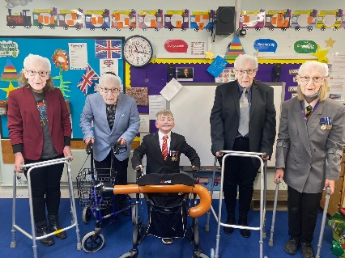

Easter egg Competition
Unfortunately we will not be having our usual Easter Bonnet parade around school this year due to the Covid-19 restrictions. We will still have a decorated egg competition with Chocolate Easter eggs as prizes. There is a theme for the decorated egg competition for each year group which links to their curriculum topic in school:
Nursery & Reception – Story Book Characters
Year One – Creature Comforts
Year Two – Inspirational People
Children are invited to bring their decorated egg to school on Friday 26th March.
The decorated eggs will be displayed in the school hall ready for judging by our Chair of Governors Mrs Christine Wilson.

Parent Phone Calls
Please remember to sign up for a suitable time slot to talk to your child’s class teacher. If you no longer have the time slot letter please phone the school office to make your appointment.
Monday 22nd March – Miss Haldenby 1pm – 6pm
Tuesday 23rd March – Mrs George 1pm - 6pm
Wednesday 24th March – Mrs Kerr 1pm – 6pm
Thursday 25th March – Miss Hiley 9am – 6pm
Year 1 and year 2 teachers will make their phone calls after the Easter holiday.

School closes on Friday 26th March for the Easter holidays and reopens on Tuesday 13th April.
Thank you for your continued support, if you have any questions or need help with anything please phone the school office, we are here to help however we can.
Best Wishes
Angela Clark
Mrs Angela Clark
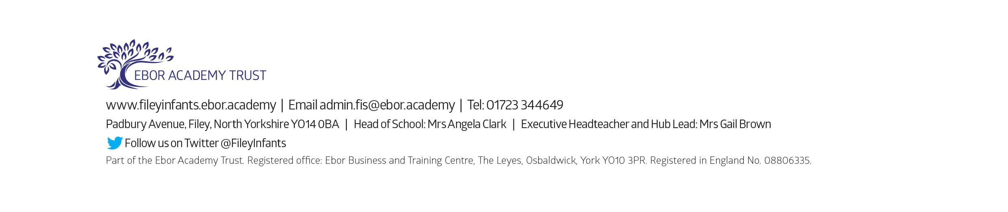
Head of School

