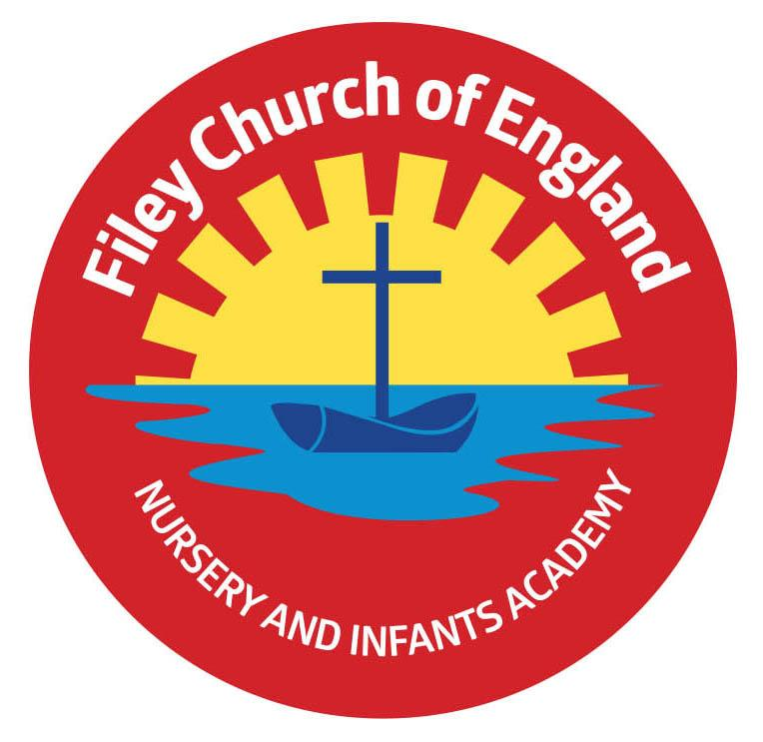
Friday 8th January 2021
Dear Parents/Carers
This has been a very difficult week for everyone and I thank you for your understanding and continued support.

Key Workers
In the interest of protecting our NHS and reducing the number of contacts I would like to ask our key worker parents to only take a place for their child in school if they have no means of keeping their child safely at home. If for example you are working from home or have a partner working opposite shifts you may be able to keep your child at home. Of course if you are a key worker and critical to the Covid-19 response a place will always be made available for your child should it be required.

Nursery
No online activities will be provided for our Nursery children due to their age and because the Government have offered all Nursery age children a place in school during this National Lockdown. If you have any questions regarding Nursery places please phone Miss Hiley via the school office on 344649.

Free School Meals
If your child is entitled to free school meals you will be receiving vouchers next week. If you have any questions regarding the voucher system, please ask Mrs Newlove in the school office.

Online Learning
Please note the online learning activities are provided through Google Classroom for Year 1 & 2 and Tapestry for our Reception classes. If your child has a login for Phonics Bug or Sumdog Maths these are extra activities that we make available, these are not part of your child’s legal education entitlement. Please see the attachment on how to access Google Classroom using an android device.

If your child is at home the expectation is that all children access online learning each working day during this National Lockdown. This is to make sure that the children working from home receive the same educational entitlement as the children working in school. I appreciate this comes with many difficulties and we want to help in any way we possibly can. If you need to borrow a school chrome book we can accommodate this request. If you would like your child’s class teacher to talk through Google Classroom or Tapestry with you, they are very willing and happy to do this.

I know these are extremely hard times we are living through and I fully understand how difficult home learning can be. Please, please if we can help in any way we will try our very best, just phone! We are here for you!

Best Wishes
Angela Clark
Head of School

