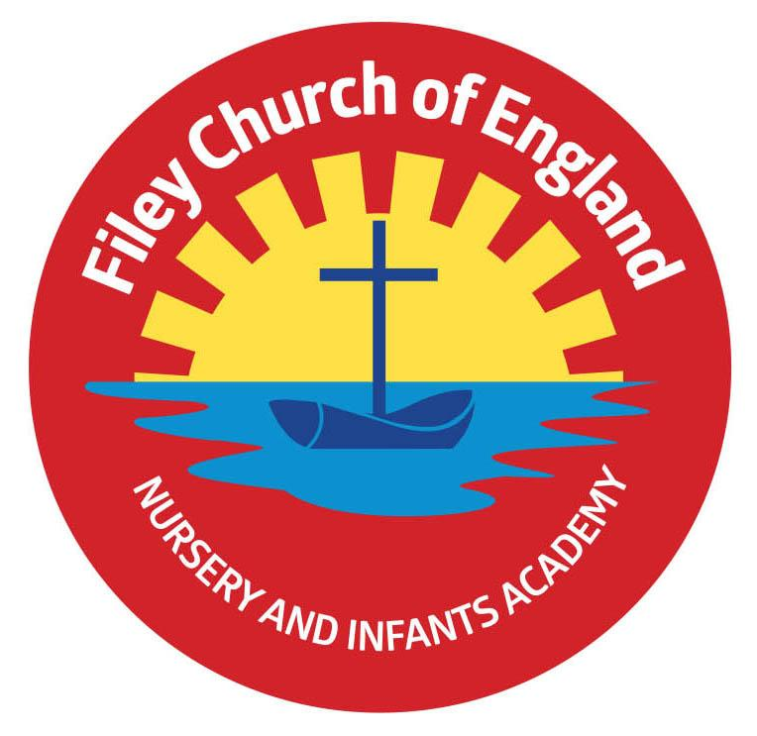
Tuesday 5th January 2021

Dear Parents/Carers
Sadly wishing everyone a Happy New Year does not seem appropriate this year and this is certainly not the letter I wanted to be sending out to you all today. However we have all been in this situation before and as always the staff here at Filey Infants will do our very best to support everyone however we can.

Key Worker Children
If you are a key worker (see the Government key worker list) and would like a place in school for your child, please phone the school office and this can be arranged. Key worker children will need to be dropped off at the main reception each morning between 8.30am and 9am. These children will then need to be collected from the main reception at the following times:
Reception – 2.50pm
Year One – 3pm
Year Two – 3.10pm
PLEASE remember to stay at least 2 metres apart from each other whilst waiting and adults must wear face coverings (unless there is a medical reason not to).
Please note if your child is allocated a key worker place in school this is a full time place (5 days a week) If your child is going to be absent you WILL need to follow the usual procedure of informing the school office.

Nursery
New Government guidance does allow all our Nursery children to attend school as normal. Their drop off times and collection times remain the same. Please use the Nursery gate for drop off and collection and DO NOT come to the main reception area. PLEASE remember to stay at least 2 metres apart from each other whilst waiting and adults must wear face coverings (unless there is a medical reason not to). If your child would normally have a school Nursery lunch this can still be provided but will be a packed lunch only. NO hot lunches will be provided during this National Lockdown. Please note that because our Nursery is open to children as normal there will be no online learning provided for these children.

On Line Learning
We have a statutory legal duty to deliver education to all our children during this National Lockdown. Class teachers will be providing the same lessons to children working at home as for the key worker children in school. It is an expectation that all children take part in the online learning provided by their teachers. If you do not have a laptop, chrome book or tablet at home please phone school and we will provide you with one for use during this lockdown. If you DO NOT have the Internet facility at home PLEASE phone school for advice regarding this matter. It is important that all children have the same access to education during this difficult time. If you have any questions, please phone 344649 we will help however we can.

Free School Meals
We are in the process of providing the voucher system again to all our families entitled to free school meals. Until these voucher codes are in place you are very welcome to collect a free school packed lunch from our main reception each day. Please let the school office know if you would like this provision.

Virtual Class Registers
Class teachers will be keeping a virtual register for all the children in their class. We have a legal responsibility to make sure all children are accounted for on a daily basis. If your child has not been active through the online learning platforms, class teachers will need to check in with you to offer support and make sure you are all well.

If you have any questions or just want to talk about a particular situation please do not hesitate to contact me on 01723 344649. As always we are here to help however we can. We are a strong community here in Filey, I am sure by helping each other and remaining as positive as possible we will get through this very difficult time.

Very Best Wishes
Angela Clark
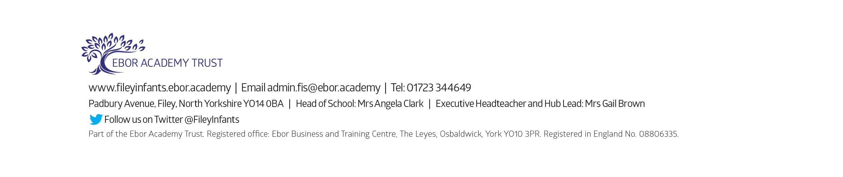
Head of School

