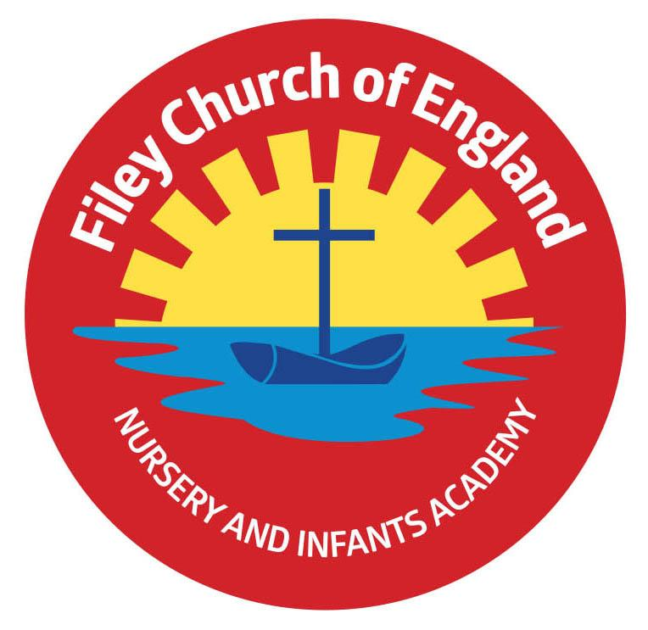
Friday 4th December 2020

Dear Parents/Carers

Today our school has been full of festive cheer…and a lot of cheeky elves!
We have had great fun raising awareness for Alzheimer’s Society and have sent a cheque for £62 from the children at Filey CE Nursery & Infants Academy. Remember to check our school tweets to see the children having fun!

Party Food
Each year we ask you to send into school a particular type of treat for the school parties.
This year we will need to collect the party treats in on Friday 11th December so they can then be left for 72 hours before we open the packets. Please could you send in the following:
Nursery & Reception – buns (the expiry date will need to be after Wednesday 16th December)
Year 1 – crisps
Year 2 - biscuits

Christmas Raffle
The raffle was drawn this afternoon and the prizes have been given out. Thank you to everyone who bought tickets, we managed to raise £448 that will go towards exciting activities for our children.

Christmas Performances
Each class will be recorded on the stage performing their Christmas production next week. These can be found on our school website in the usual place - TEACHING & LEARNING – Classes – Your child’s class teacher’s name.

The Snow Queen
Year 1 and year 2 children will visit the Stephen Joseph Theatre on Thursday 10th December to see ‘The Snow Queen’. This year school will be covering the cost of this exciting visit so no payment needs to be made. We will of course be following a detailed Covid-19 risk assessment to make this visit as safe as possible. If you do not want your child to take part in this visit please inform the school office before Tuesday 8th December.

Christmas Lunch
Traditional Christmas dinner will be served on Friday 11th December, there will be NO sandwich or jacket potato option on this day. If your child will not eat a Christmas dinner they will need to bring a packed lunch on this day. Children are also invited to wear a Christmas jumper on this day if they would like to.

Christmas Cards
The last day to bring Christmas cards into school will be Monday 14th December. This is so they can be left for 72hours before being given out on the last day Friday 18th December.

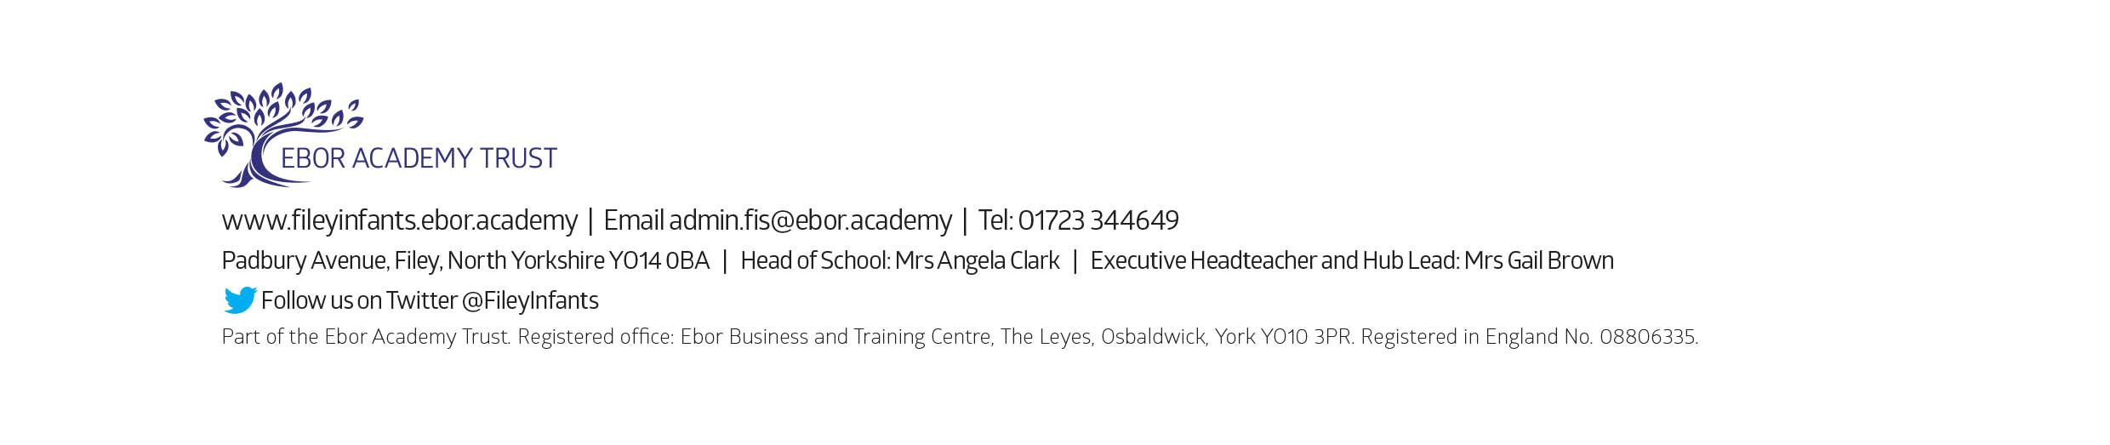
Best Wishes
Mrs Angela Clark
Head of School

