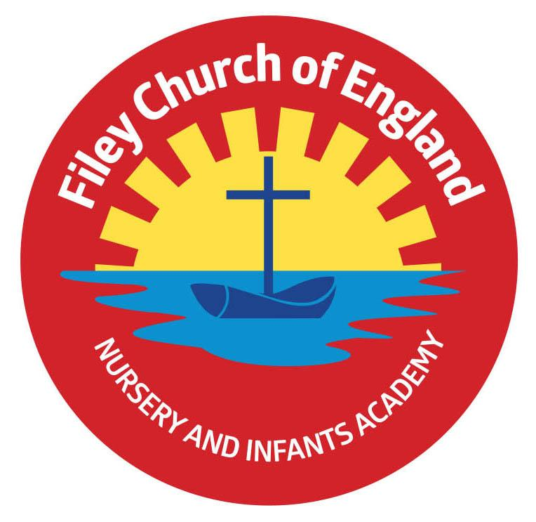
Friday 11th December 2020

Dear Parents/Carers
Wow! What a wonderful week we have had in school.

Christmas Productions
The Christmas productions have all been fantastic, I enjoyed every one. Please remember to watch these on our school website, they can now all be found in the usual place:
TEACHING & LEARNING – Classes – then the class teacher’s name.

Christmas Production Photographs
This year teachers have taken photographs of your children after their productions.
Mrs Newlove will be sending these photographs to everyone via your email address next week. Please let us know if you do not receive these lovely keepsakes.

Christmas Dinner
Christmas dinner was a big success, thank you to all our kitchen and lunchtime staff for making this so special.

The Snow Queen
Our year one and year two children loved ‘The Snow Queen’ production at The Stephen Joseph Theatre on Thursday, I am so happy we could make this happen with all the Covid-19 restrictions in place. It was truly magical…a special thanks to Diana and all the theatre staff for helping to make this possible.

Christmas Parties
Next week our year one and year two children will have their Christmas party on Tuesday 15th December and Nursery and Reception children will have their party on Wednesday 16th December. Children are invited to come to school on that day in their party clothes.

4Front Theatre Company
On Thursday 17th December we will be having a live streaming of ‘A Very Merry Covid Cancelled Christmas’ from 4Front Theatre Company. This is a treat for all classes to enjoy by watching it on the white boards in their classrooms.

Cool Milk
Just a reminder that if you want your child to have milk during the school day this can be ordered and paid for via www.coolmilk.co.uk Please note children under the age of five are already provided with milk free of charge.

Breakfast
Each class has a breakfast table in their classroom on a morning if you would like your child to have breakfast when they arrive at school. A choice of cereal and toasted bagels are provided free of charge every morning ready for when the children arrive.

Christmas Cards
Monday 14th December is the last day to bring Christmas cards to school so we are able to leave them 72 hours before they are given out.

Communication
Due to Covid-19 restrictions and parents not freely moving around the school site as normal I appreciate communication with your child’s teacher is more difficult than usual. Staff are on the school gates every day for drop off and collection times, so messages can be given then. Newsletters are sent out via your email address most Fridays and are always posted under ‘Latest News’ on our school website (please make sure you keep us up to date with any changes to your contact details). We also send a text message to your child’s primary contact alerting them that a newsletter has been sent and posted on the school website. You are always welcome to phone the school office if you have any questions or concerns.

You will have received a letter on Wednesday explaining the government’s invitation for all schools to consider using next Friday 18th December, as a teacher training day. We have declined this offer and will be open as normal on this day. School then reopens on Tuesday 5th January 2021.

Once again I thank you all for your wonderful support and kind words. If you have any concerns or questions please phone us on 344649 we are here to help however we can.

Best Wishes
Angela Clark
Mrs Angela Clark
Head of School

