Four yoga poses for you to try

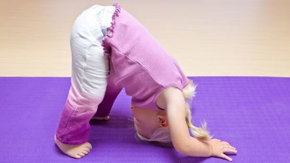
Downward-Facing Dog
Come to hands and knees on the floor with spread fingers. Push your palms into the ground while lifting your hips (or “tail”) into the air and straightening your legs. Let your head hang and gaze between your knees. Feet do not have to be flat on the floor but should be about hip distance apart with heels comfortably aiming for the ground. Try to take 4 long slow deep breaths in through the nose and out through the mouth.

Tree Pose

Stand tall with feet hip distance apart. Slowly lift one foot up placing it either on the ankle or thigh of the standing leg (never the knee). Bring your hands to your heart and find something that is not moving to look at. This is called your drishti. When you feel still and balanced try bringing your hands to the sky like branches of a strong sturdy tree.

Mountain Pose
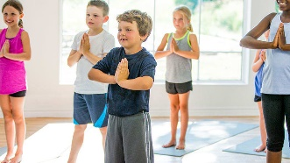
Stand with your feet hip-distance apart. Roll your shoulders back and down, palms facing forward. Imagine the top of your head reaching to the sky. Feel your entire foot on each side connecting to the ground like the strong base of your mountain. Close your eyes and imagine you are strong and sturdy. Breathe in and out slowly through your nose. You are a strong and beautiful mountain.

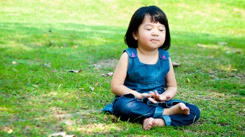
Belly Breath
Take 10 slow, deep breaths, breathing all the way down into the belly. Put your hands on your belly and feel your hands going up and down with your breath.

