Butterfly Shape

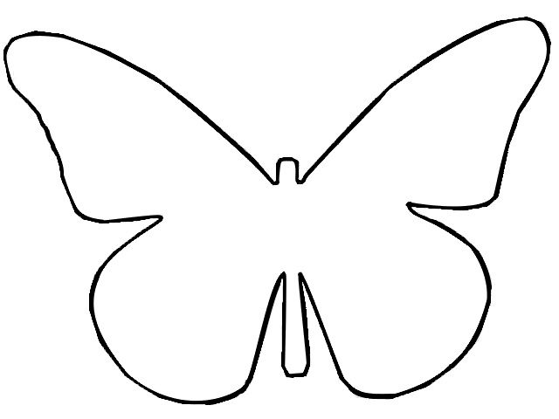

Butterfly poem – interactive.
Butterfly, butterfly, flutter around,
Butterfly, butterfly, touch the ground.
Butterfly, butterfly, fly so free,
Butterfly, butterfly, land on me.
Butterfly, butterfly, reach the sky,
Butterfly, butterfly, say good-bye!

