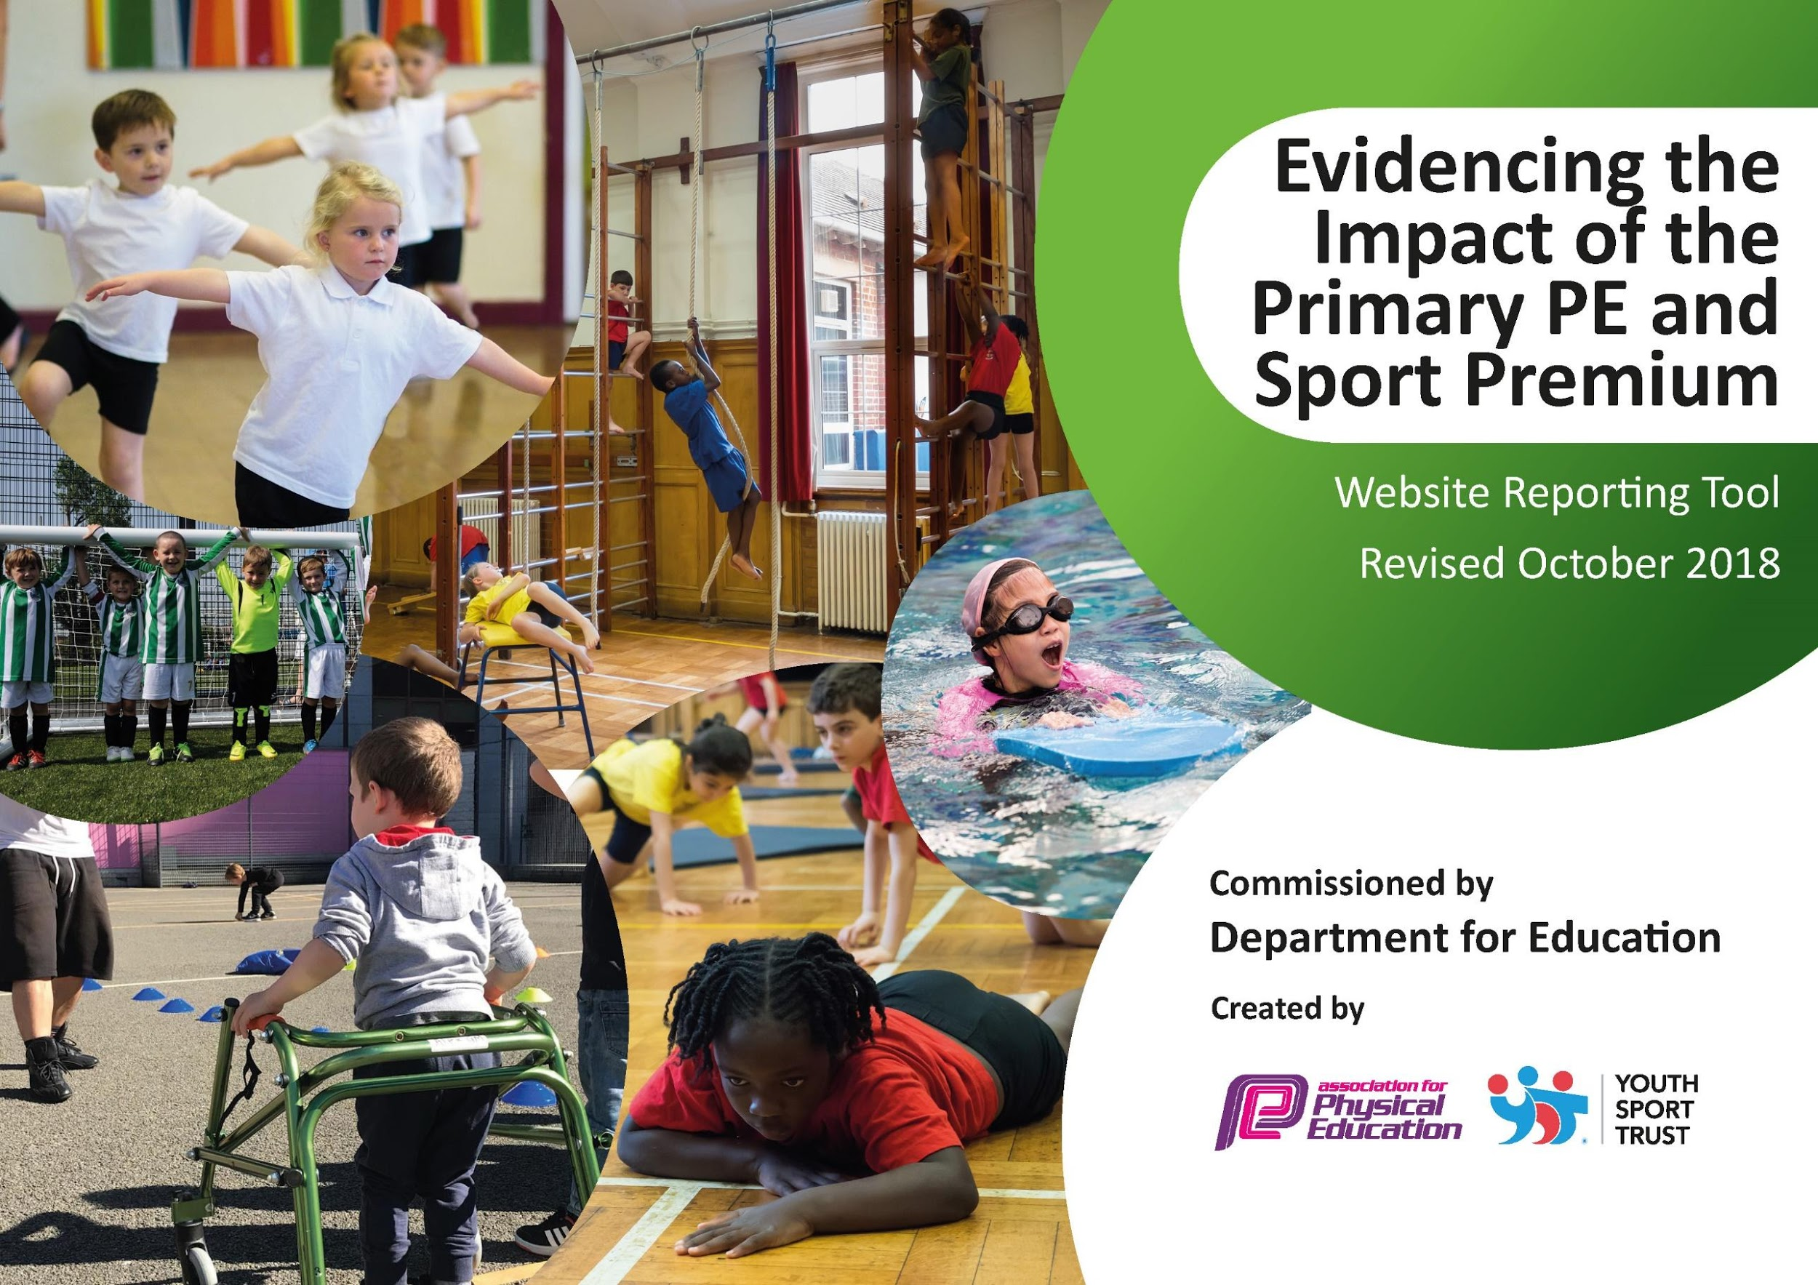
s

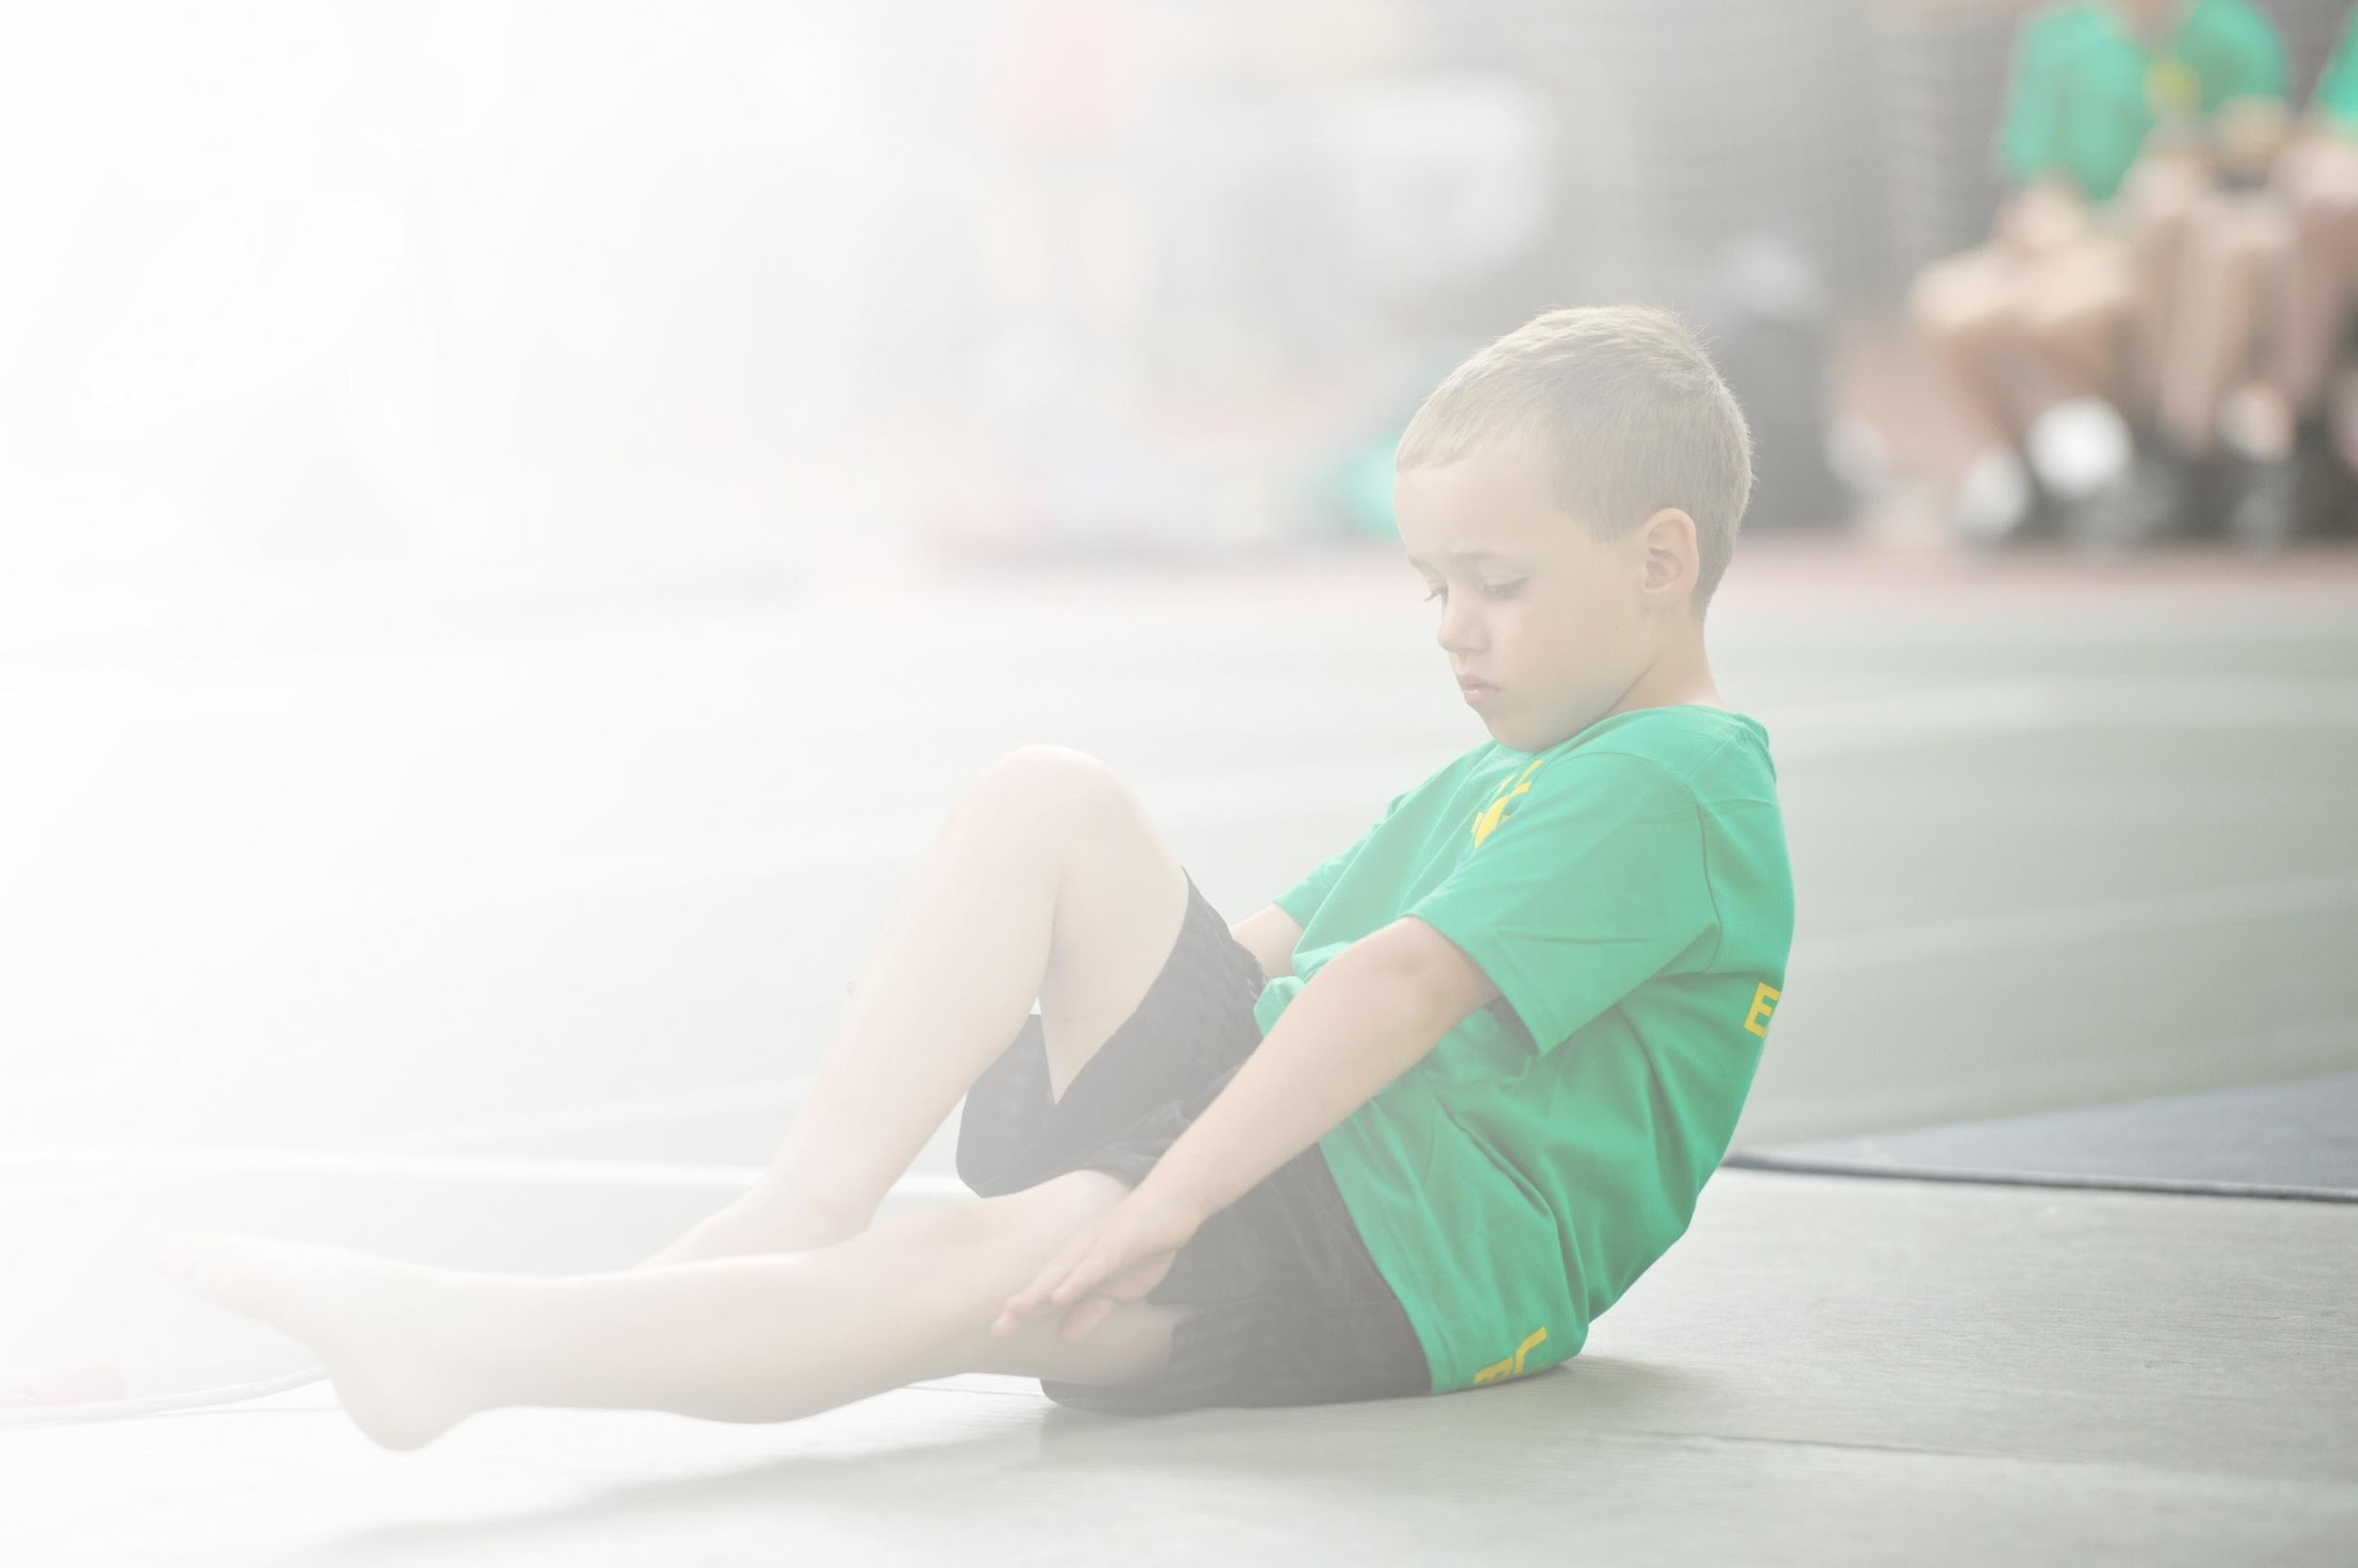
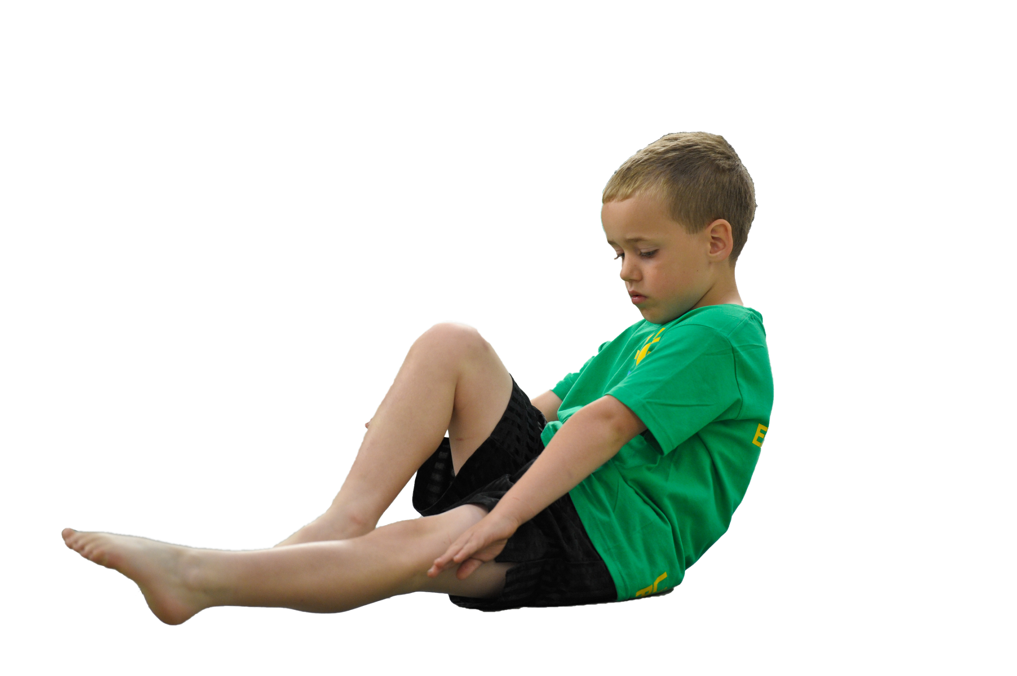
Schools must use the funding to make additional and sustainable improvements to the quality of Physical Education, Sport and Physical Activity (PESPA) they offer. This means that you should use the Primary PE and Sport Premium to:

- Develop or add to the PESPA activities that your school already offer
- Build capacity and capability within the school to ensure that improvements made now will benefit pupils joining the school in future years

Please visit gov.uk for the revised DfE guidance including the 5 key indicators across which schools should demonstrate an improvement. This document will help you to review your provision and to report
your spend. DfE encourages schools to use this template as an effective way of meeting the reporting requirements of the Primary PE and Sport Premium.

We recommend you start by reflecting on the impact of current provision and reviewing the previous
spend. Under the Ofsted Schools Inspection Framework, inspectors will assess how effectively leaders use the Primary PE and Sport Premium and measure its impact on outcomes for pupils, and how effectively governors hold them to account for this.

Schools are required to publish details of how they spend this funding as well as on the impact it has on pupils’ PE and sport participation and attainment by the end of the summer term or by 31 July 2019 at the
latest.
We recommend regularly updating the table and publishing it
on your website throughout the year, as evidence of your
ongoing review into how you are using the money to
secure maximum, sustainable impact. To see an
example of how to complete the table please
click HERE.

Support for review and reflection - considering the 5 key indicators from DfE, what development needs are a priority for your setting and your students now and why? Use the space below to reflect on previous spend, identify current need and priorities for the future.

Key achievements to date: | Areas for further improvement and baseline evidence of need:
What has Filey done well so far? Draw upon competition successes, schools games, staff CPD programme in place.  Specialist sports teacher engages children in inter-school coast area competitions such as gymnastics and various athletics. Some pupils have represented Filey Infants in Gymnastics and Quadkids competitions.  Specialist teacher works with staff to upskill (Nursery- Year 2). Staff feel more confident in delivering PE. From including Nursery, our children are able to build confidence from a young age and start seeing the benefits of being physically active.  Specialist teacher delivers CPD and team teaches with staff on a weekly basis. Pupils have been offered a broad curriculum and there are extra curricular activities available to them.  Introduction of swimming lessons for Year 1 and Year 2.  Play leaders introduced to encourage and support physical and active break times. | This is the opportunity to talk about your action plan and how you want to improve it this year. How are you going to do it? How could the funding support?  After a review of this years curriculum offered, we want to offer a broad range to our pupils in 2019-20. To go alongside our curriculum, we would like to trial an informative assessment system that will help support staff and pupils.  To continue the use of the sports specialist teachers to upskill new members of staff that are joining our school 2019-20. Provision for these new staff (CPD and team teaching).  We want to use technology more to support staff in PE to help with assessment to make sure that children are meeting the required amount of physical activities.  We are hoping to offer children more offsite activities, such as sports events.

Meeting national curriculum requirements for swimming and water safety | Please complete all of the below:
What percentage of your current Year 6 cohort swim competently, confidently and proficiently over a distance of at least 25 metres?  N.B. Even though your children may swim in another year please report on their attainment on leaving  primary school. | % Refer to swimming trackers  N/A
What percentage of your current Year 6 cohort use a range of strokes effectively [for example, front crawl, backstroke and breaststroke]? | %  N/A
What percentage of your current Year 6 cohort perform safe self-rescue in different water-based situations? | %  N/A
Schools can choose to use the Primary PE and Sport Premium to provide additional provision for swimming but this must be for activity over and above the national curriculum requirements. Have you used it in this way? | Yes/No  Swimming is not compulsory for KS1 so it is an additional activity to normal expectations.

Action Plan and Budget Tracking
Capture your intended annual spend against the 5 key indicators. Clarify the success criteria and evidence of impact that you intend to measure to evaluate for students today and for the future.

Academic Year: 2018/19 | Total fund allocated: £17270 | Date Updated: 19/6/19
Key indicator 1: The engagement of all pupils in regular physical activity – Chief Medical Officer guidelines recommend that primary school children undertake at least 30 minutes of physical activity a day in school |  |  |  | Percentage of total allocation:
 |  |  |  | %
School focus with clarity on intended impact on pupils: | Actions to achieve: | Funding allocated: | Evidence and impact: | Sustainability and suggested next steps:
Active break times. Ensure that a range of activities are available for children to take part in at break times. Ensure that play leaders are seen to be a positive role model around school. Ensure that the equipment is put out in the mornings and put away at the end of the day. By doing this we hope to see more physically active children resulting in better concentration and behaviour. | Observations of break time and lunchtime activity by subject leader. Ensure all staff are aware of the role of lunch time leaders and what they are promoting. Children are all engaged in physical activity that lasts for at least 30 minutes a day.  Active break time resources ordered. | £423 | Through observation, more children are engaged in physical activity at playtimes.  Equipment is used and lunchtime leaders make sure it is used correctly and sensibility  Lower behaviour incidents have been noted through lunch time records and accidents have reduced since this was introduced. | Should the funding stop, all play leaders will have been trained on how to use the equipment safely. Training of new play leaders leaders.  Maintenance of equipment.
Key indicator 2: The profile of PESSPA being raised across the school as a tool for whole school improvement |  |  |  | Percentage of total allocation:
 |  |  |  | %
School focus with clarity on intended impact on pupils: | Actions to achieve: | Funding allocated: | Evidence and impact: | Sustainability and suggested next steps:

Key indicator 3: Increased confidence, knowledge and skills of all staff in teaching PE and sport |  |  |  |  | Percentage of total allocation:
 |  |  |  |  | %
School focus with clarity on intended  impact on pupils: | Actions to achieve: | Funding  allocated: |  | Evidence and impact: | Sustainability and suggested  next steps:
External Specialist Coaches will work alongside teachers to deliver programmes. This will give our teaching staff a better knowledge and ideas to put into their future PE lessons thus enhancing the quality of teaching for pupils.  Sports include: Bicycling, Golf, Yoga, Football, Climbing, Cricket.  Employment of specialist sports teacher to deliver and work alongside teachers and support staff in teaching PE. In doing this, pupils should receive high quality PE and staff should feel more confident to deliver high quality PE.  Ebor Academy Trust contribution to PE curriculum and development coordinator to upskill staff and provide the best outcomes for pupils. | Arrange times for specialists to come into school and identify teachers for specialists to work with. Internal sports teacher (TE) to book in times and liaise with subject lead.  Discuss program of delivery with Sports teacher and set expectations. Book Sports Teacher for relevant times and dates. ST to Deliver lessons across the school. Working alongside staff to up-skill class teachers. Staff CPD. Extra curricular clubs introduced.  Subject leader to liaise and arrange a Visit to school to work with PE coordinator. Filey Infants to attend any training/Moderation hosted by Ebor. | £850  £9225.  £2000 |  | In Autumn term Kim meadows from British cycling  Ready. Set. Ride. came to work with Reception on a  Cycling project introducing learning ride.  Matthew Hurren from Yorkshire Cricket worked with Year 1 and Year 2 in April and May. A Year two child said ‘’I love it when special teachers come into school because we get to experience real sports’’. One teacher said ‘’The children have started to use specialist vocabulary to talk about sports and they are much more engaged in lessons’’.  Children recognise, enjoy and talk about a variety of healthy sporting options. Teambuilding, decision making and resilience has developed and improved. Ongoing regular activity team engagement.  PE lessons delivered at a high standard by professionally accredited PE teacher from September- July for 1 day a week.  Coverage of all classes with class teacher in attendance/ team teaching.  Around 30% of children attend extra curricular clubs led by the sports specialist. This has also led to greater participation in competitions.  Website always compliant.  Initial visit to Filey Infants in Autumn term to meet SLT and Subject leader.  Network meeting and CPD event in spring term. Pre moderation day visit in summer term to work with subject leader. PE moderation day in Summer term and follow up visit to work with Subject leader. As a result in training and support, Subject leader has been able to cross moderate website reports, network and share good practice. Curriculum maps have been shared. | Teachers to share their planning with other staff members to make the programme sustainable. Deliver sessions independently to build confidence.  Subject leader to observe teaching in next school year to check impact and quality.  From the subject leader speaking to staff, it is clear that staff have acquired new skills and in depth knowledge for delivery of PE lessons and how PE can be linked to other activities.  Subject leader to audit staff by google form to check confidence levels and plan ahead for 2019-20. Subject leader to track teachers in future lessons to see the impact of high quality PE. Subject leader to identify new teachers that would benefit from this in the next academic year. Should the money stop, ensure that all teachers are confident in delivering high quality PE independently and confidently.  Subject leader to liaise with Ebor specialist to develop and trial a successful assessment strategy for 2019-20. Subject leader to share with staff at school.
Key indicator 4: Broader experience of a range of sports and activities offered to all pupils |  |  |  |  | Percentage of total allocation:
 |  |  |  |  | %
School focus with clarity on intended  impact on pupils: | Actions to achieve: | Funding  allocated: |  | Evidence and impact: | Sustainability and suggested  next steps:
Being a coastal school with a large number of pupils unable to access swimming locally, we intend on providing swimming lessons to all KS1 children to attain water confidence and competence in early swimming skills. With swimming not being recognised on the KS1 curriculum, we see this as offering a broader range of activities.  We want to provide dance provision opportunities to allow our pupils to have a wider range of cultural experiences, to broaden the children's experiences and expose to more.  LOTC extended to use outdoor local environment for active physical well being of pupils and staff and to broaden opportunities and experiences. | Source quotes from local pools. Arrange times and dates to visit, Book slots. Arrange travel. Inform teachers and parents of information.  Speak with Stephen Joseph Theatre to look at the packages available to our school. Book packages and make staff aware of what is happening. Throughout the program pupils will experience Stomp, Dancing Maths, African drums and chinese movement.  Timetable a list of events throughout the academic year. Share timetable with staff. Plan activities. | RSA Swimming teacher £1006  Coach to swimming pool £2975  Hire of pool and lifeguard £1400.  £850  £500 including transport. |  | A time table of swimming was devised and children have swum from September to July. From observations and sharing of assessment from swimming teacher, it is clear that the children have gained water confidence and attained a lifelong skill of swimming, as well as having enjoyment of being in a swimming pool. 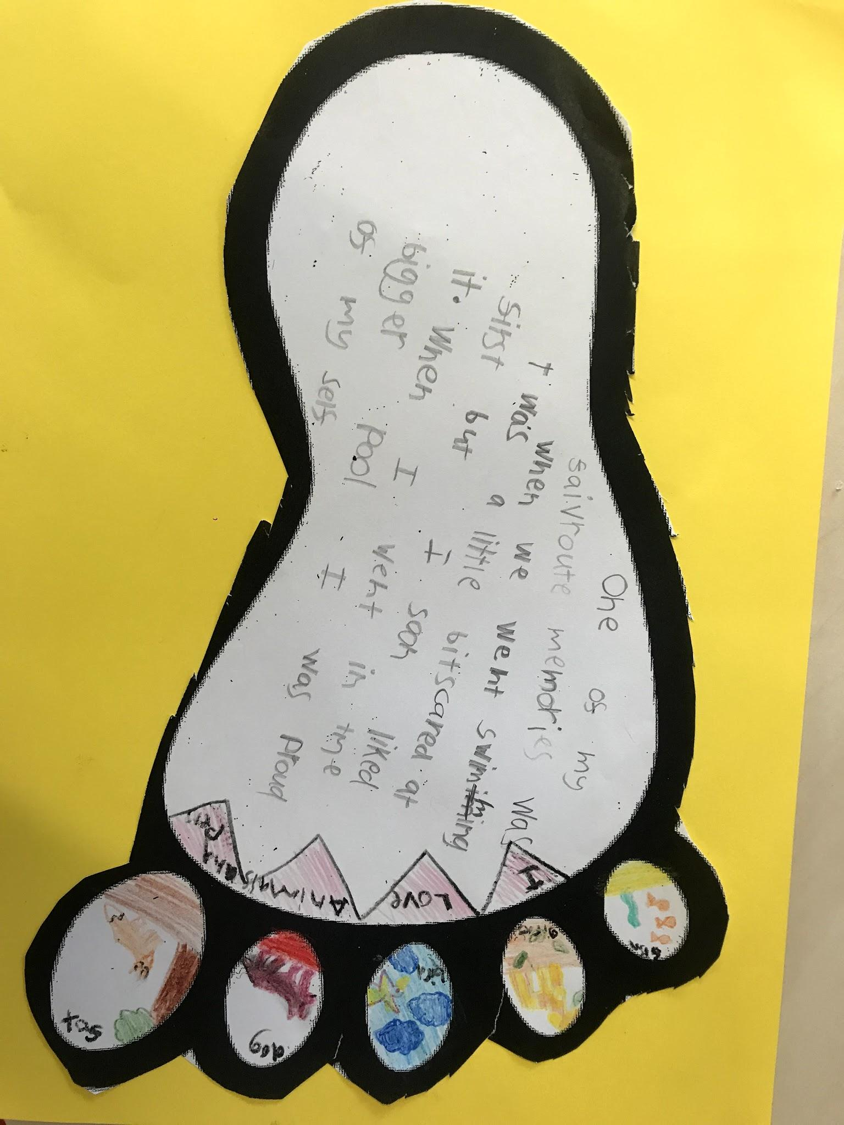  ‘’One of my favourite memories was when we went swimming. I was a little bit scared at first but I soon liked it when I went in the bigger pool. I was proud of myself’’.  In Autumn term, spring term and summer term… Stephen Joseph Theatre worked with Filey Infants Staff and pupils experienced Physical dance and enjoyment with multicultural awareness and music around the world. Through observations and comments from staff, team work skills have improved and there has been a raised awareness of impact on health and heart fitness and enjoyment (physical health and wellbeing). Social interaction and team building has improved and increased decision making and problem solving (mental wellbeing) has improved also.  Class attended activities such as Beach and forest days. These included walking, shelter building and orienteering. Teachers placed a strong focus on social interaction and team building. Subject leader noticed a strong difference in working collaboratively across the school and in lessons. | Review the program of swimming. Look into developing staff to qualify and teach quality swimming lessons. To liaise with local Ebor partner school to develop swimming gala for 2019-20.  Liaise with SJT to see what packages are available next year. Should the funding stop, Staff to look at delivering similar programs that they feel confident in doing.  Teachers to promote skills learnt in classrooms and subject leader to continue to seek similar opportunities with low costs and keep reviewing the program.
Key indicator 5: Increased participation in competitive sport |  |  |  |  | Percentage of total allocation:
 |  |  |  |  | %
School focus with clarity on intended  impact on pupils: | Actions to achieve: | Funding  allocated: |  | Evidence and impact: | Sustainability and suggested  next steps:
We would like to Increase participation rates in inter/ intra school events and competitions to our children exposure to competive sporting events. | Buy into membership of the Scarborough district primary school sports association.  Increase the range of extracurricular opportunities and promote clubs to all parents and pupils.  Registers and calendars cross referenced against school games mark criteria. | £50 |  | Through registers and activity trackers, a larger amount of children are attending inter and intra school opportunities.  Competitions we have had access to have been Quadkids, Gymnastics and Cross country.  We have been able to establish a strong culture of teamwork and staff have embedded these values in everyday teaching. Subject leader has noticed children’s attitudes towards sport is high and very positive. | Continue to track pupils and target certain events. We have recognised there is not a lot of opportunity in our area for KS1 competitions so we are going to work with our school PE teacher Specialist to tailor a program to suit our needs.

